Area Equality
# Source: AI Source: Provided by: [Data Path: Persons Table -> ID Column: 1, Name_En Column: Motasem Essam] -> From: [ChatGPT] on [7/25/2026]
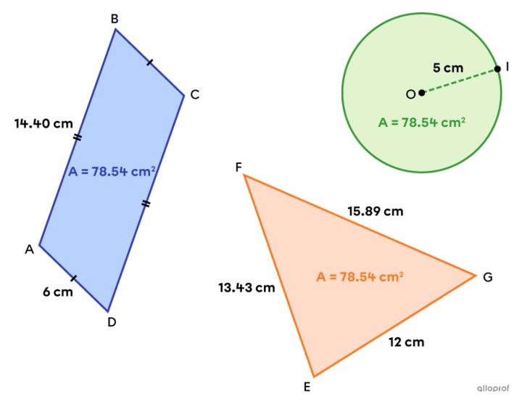
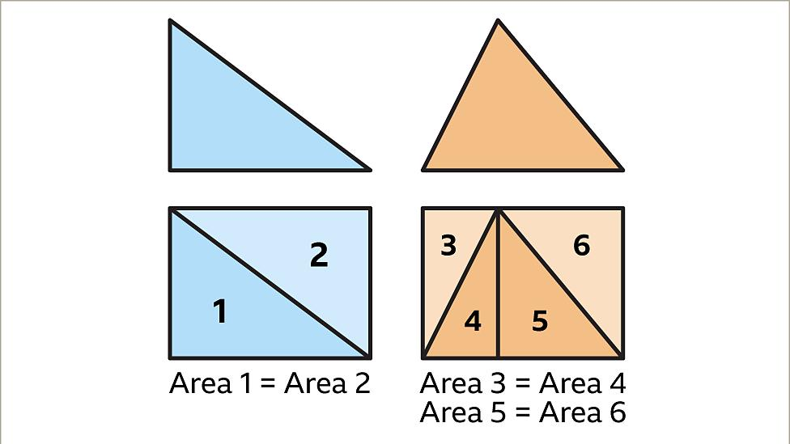
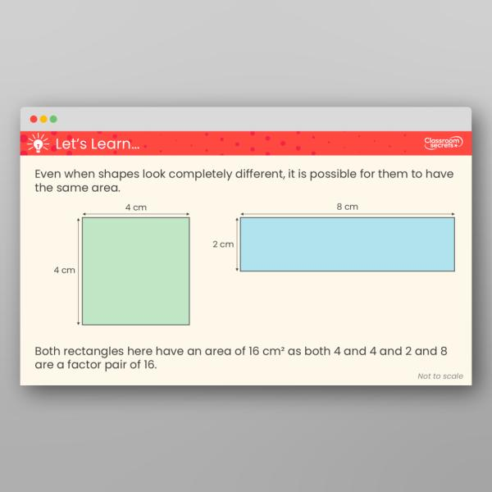
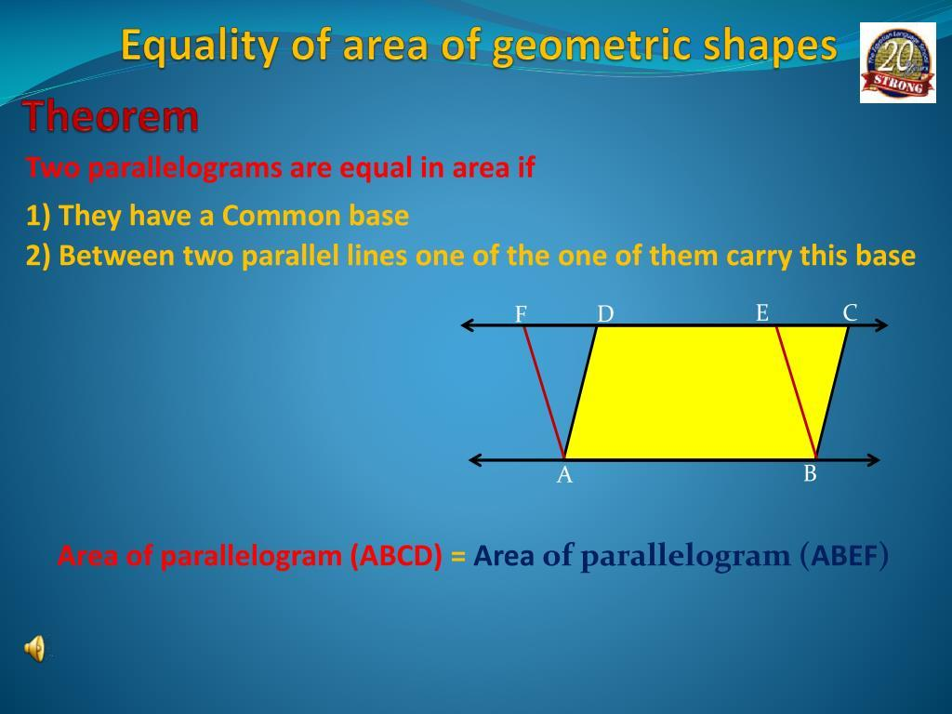

Definition
# Source: AI Source: Provided by: [Data Path: Persons Table -> ID Column: 1, Name_En Column: Motasem Essam] -> From: [ChatGPT] on [7/25/2026]
Area Equality is an exact geometric relationship in which two or more two-dimensional figures or regions have the same area.
It is represented by:
$$\boxed{A_{1}=A_{2}}$$
where $A_{1}$and $A_{2}$are the areas of two geometric figures or regions.
For example:
$$A_{1}=24{\text{ cm}}^{2}$$
and:
$$A_{2}=24{\text{ cm}}^{2}$$
Therefore:
$$\boxed{A_{1}=A_{2}}$$
The figures do not need to have the same shape or dimensions.

Simple Definition
# Source: AI Source: Provided by: [Data Path: Persons Table -> ID Column: 1, Name_En Column: Motasem Essam] -> From: [ChatGPT] on [7/25/2026]
Area Equality means that two or more regions occupy exactly the same amount of two-dimensional space.
For example, a rectangle and a triangle can have the same area even though their shapes are different.

Fundamental Concept
# Source: AI Source: Provided by: [Data Path: Persons Table -> ID Column: 1, Name_En Column: Motasem Essam] -> From: [ChatGPT] on [7/25/2026]
Area measures the amount of two-dimensional region enclosed by a figure.
Area equality means:
$$\boxed{\text{Area of Figure 1}=\text{Area of Figure 2}}$$
For example:
$$\text{Rectangle: }6×4=24$$
and:
$$\text{Triangle: }\frac{1}{2}\left(8\right)\left(6\right)=24$$
Therefore:
$$\boxed{A_{\text{rectangle}}=A_{\text{triangle}}=24{\text{ cm}}^{2}}$$
Important
Area equality does not mean the figures are congruent.
Two completely different shapes can have the same area.

Types of Area Equality
# Source: AI Source: Provided by: [Data Path: Persons Table -> ID Column: 1, Name_En Column: Motasem Essam] -> From: [ChatGPT] on [7/25/2026]
The following is a practical classification of common ways area equality is established in geometry. It is not a single universally standardized classification.
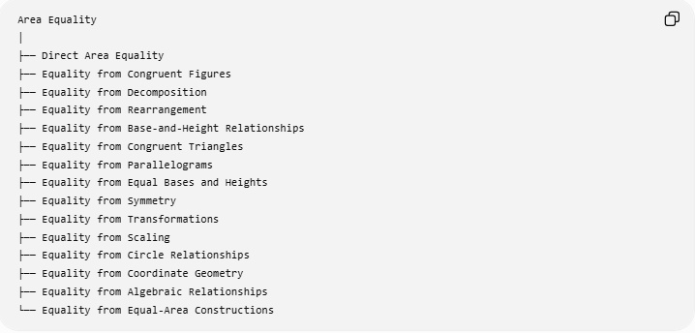
Area Equality
│
├── Direct Area Equality
├── Equality from Congruent Figures
├── Equality from Decomposition
├── Equality from Rearrangement
├── Equality from Base-and-Height Relationships
├── Equality from Congruent Triangles
├── Equality from Parallelograms
├── Equality from Equal Bases and Heights
├── Equality from Symmetry
├── Equality from Transformations
├── Equality from Scaling
├── Equality from Circle Relationships
├── Equality from Coordinate Geometry
├── Equality from Algebraic Relationships
└── Equality from Equal-Area Constructions

Direct Area Equality
# Source: AI Source: Provided by: [Data Path: Persons Table -> ID Column: 1, Name_En Column: Motasem Essam] -> From: [ChatGPT] on [7/25/2026]
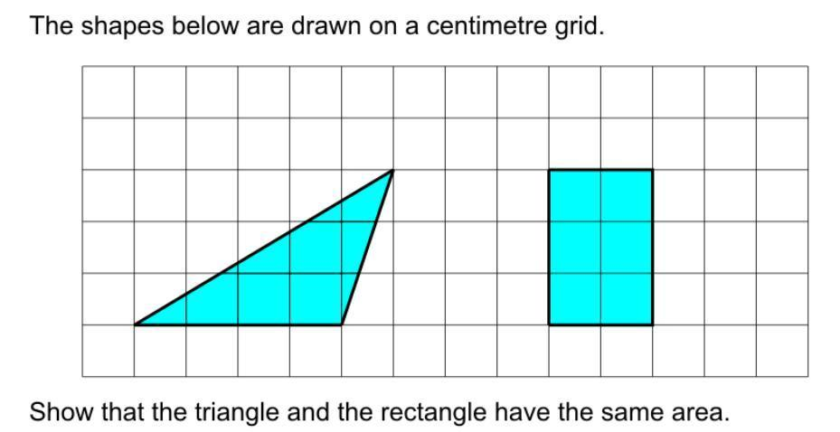
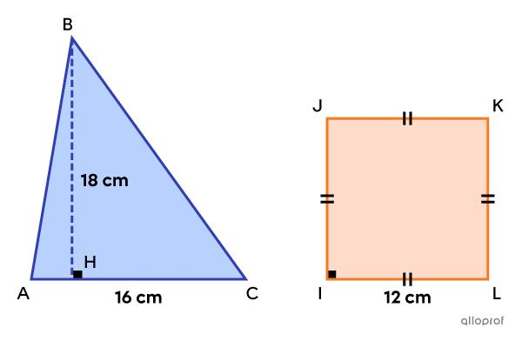
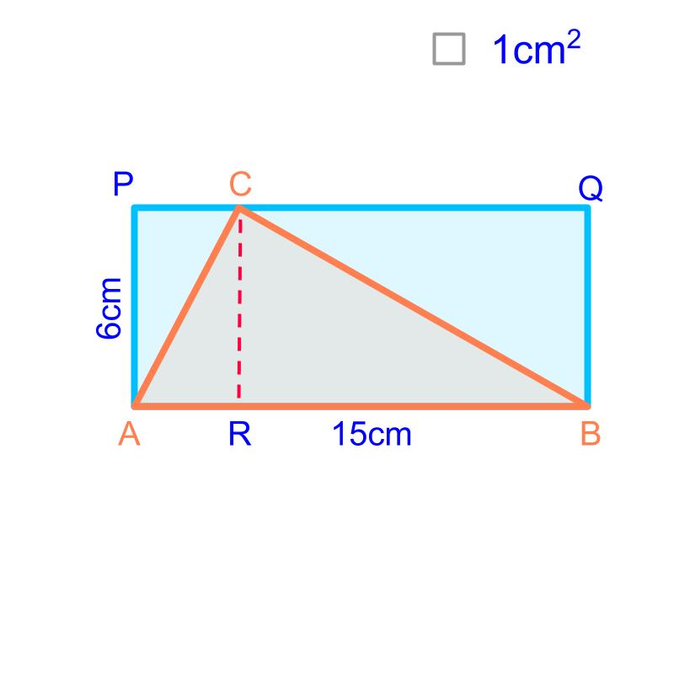
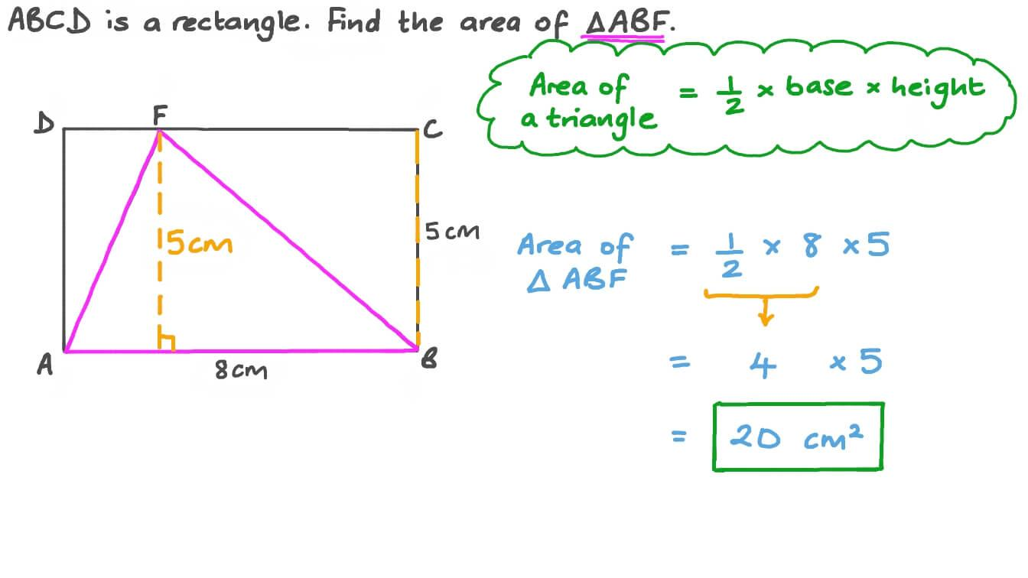
Definition
Area equality may be given directly:
$$\boxed{A_{1}=A_{2}}$$
Example
Suppose:
$$A_{1}=50{\text{ cm}}^{2}$$
and:
$$A_{2}=50{\text{ cm}}^{2}$$
Then:
$$\boxed{A_{1}=A_{2}}$$
The two regions have equal area regardless of their shapes.

Equality from Congruent Figures
# Source: AI Source: Provided by: [Data Path: Persons Table -> ID Column: 1, Name_En Column: Motasem Essam] -> From: [ChatGPT] on [7/25/2026]

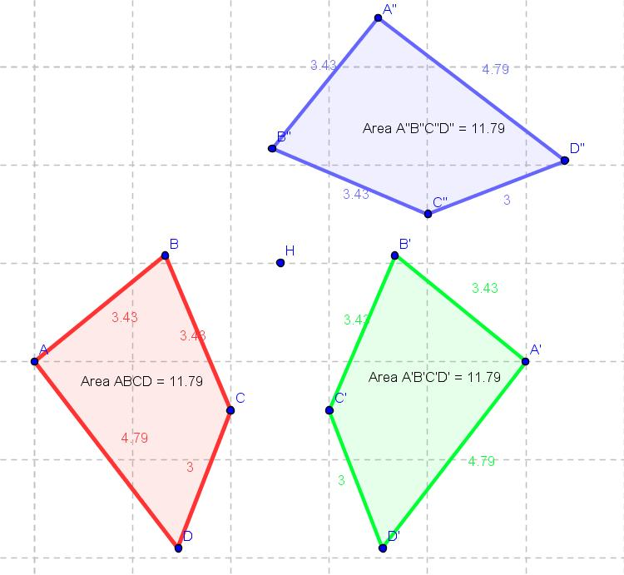
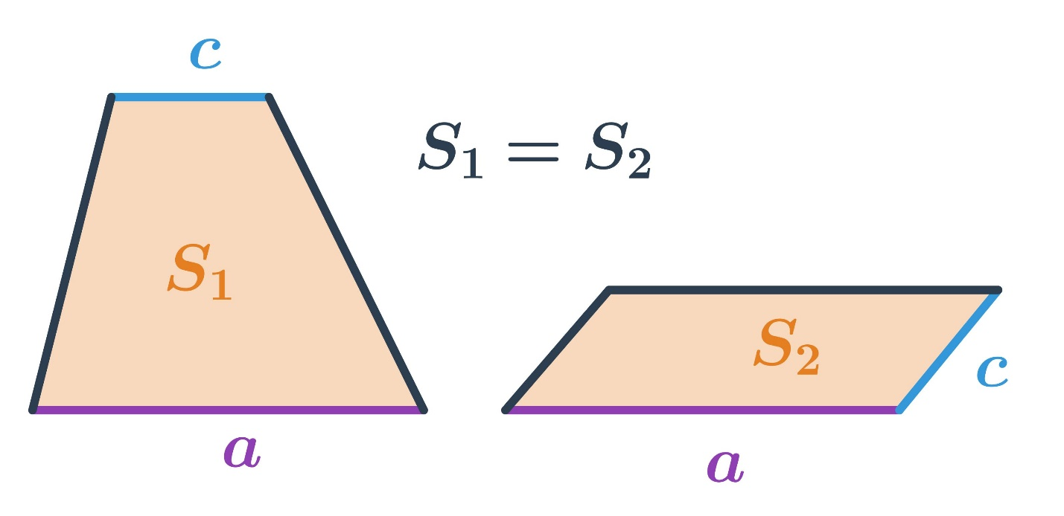
Definition
Congruent figures have the same shape and size. Therefore, their areas are equal.
If:
$$F_{1}≅F_{2}$$
then:
$$\boxed{A_{1}=A_{2}}$$
Example
If two congruent rectangles each have dimensions:
$$5\text{ cm}×8\text{ cm}$$
then:
$$A_{1}=A_{2}=5\left(8\right)=40{\text{ cm}}^{2}$$
Thus:
$$\boxed{A_{1}=A_{2}=40{\text{ cm}}^{2}}$$
Important
Congruence guarantees area equality, but area equality does not guarantee congruence.

Equality from Decomposition
# Source: AI Source: Provided by: [Data Path: Persons Table -> ID Column: 1, Name_En Column: Motasem Essam] -> From: [ChatGPT] on [7/25/2026]

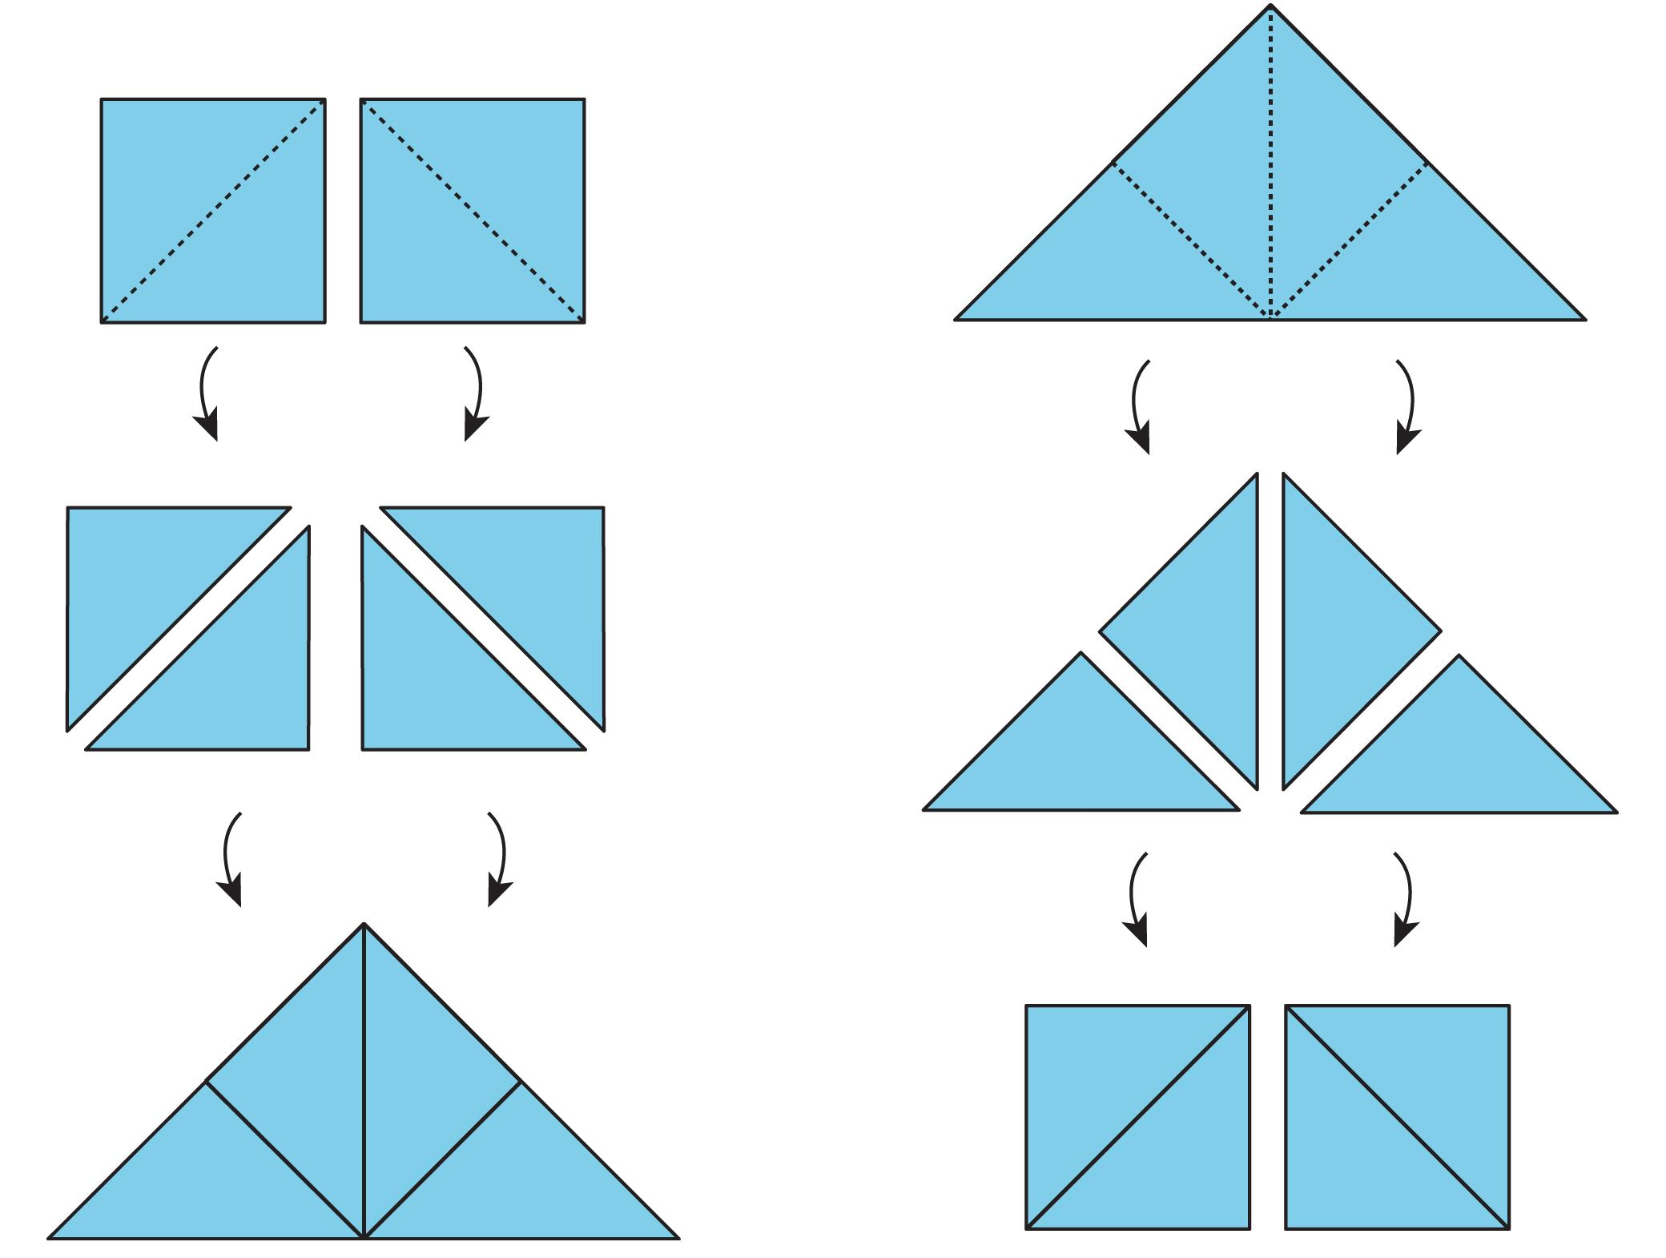
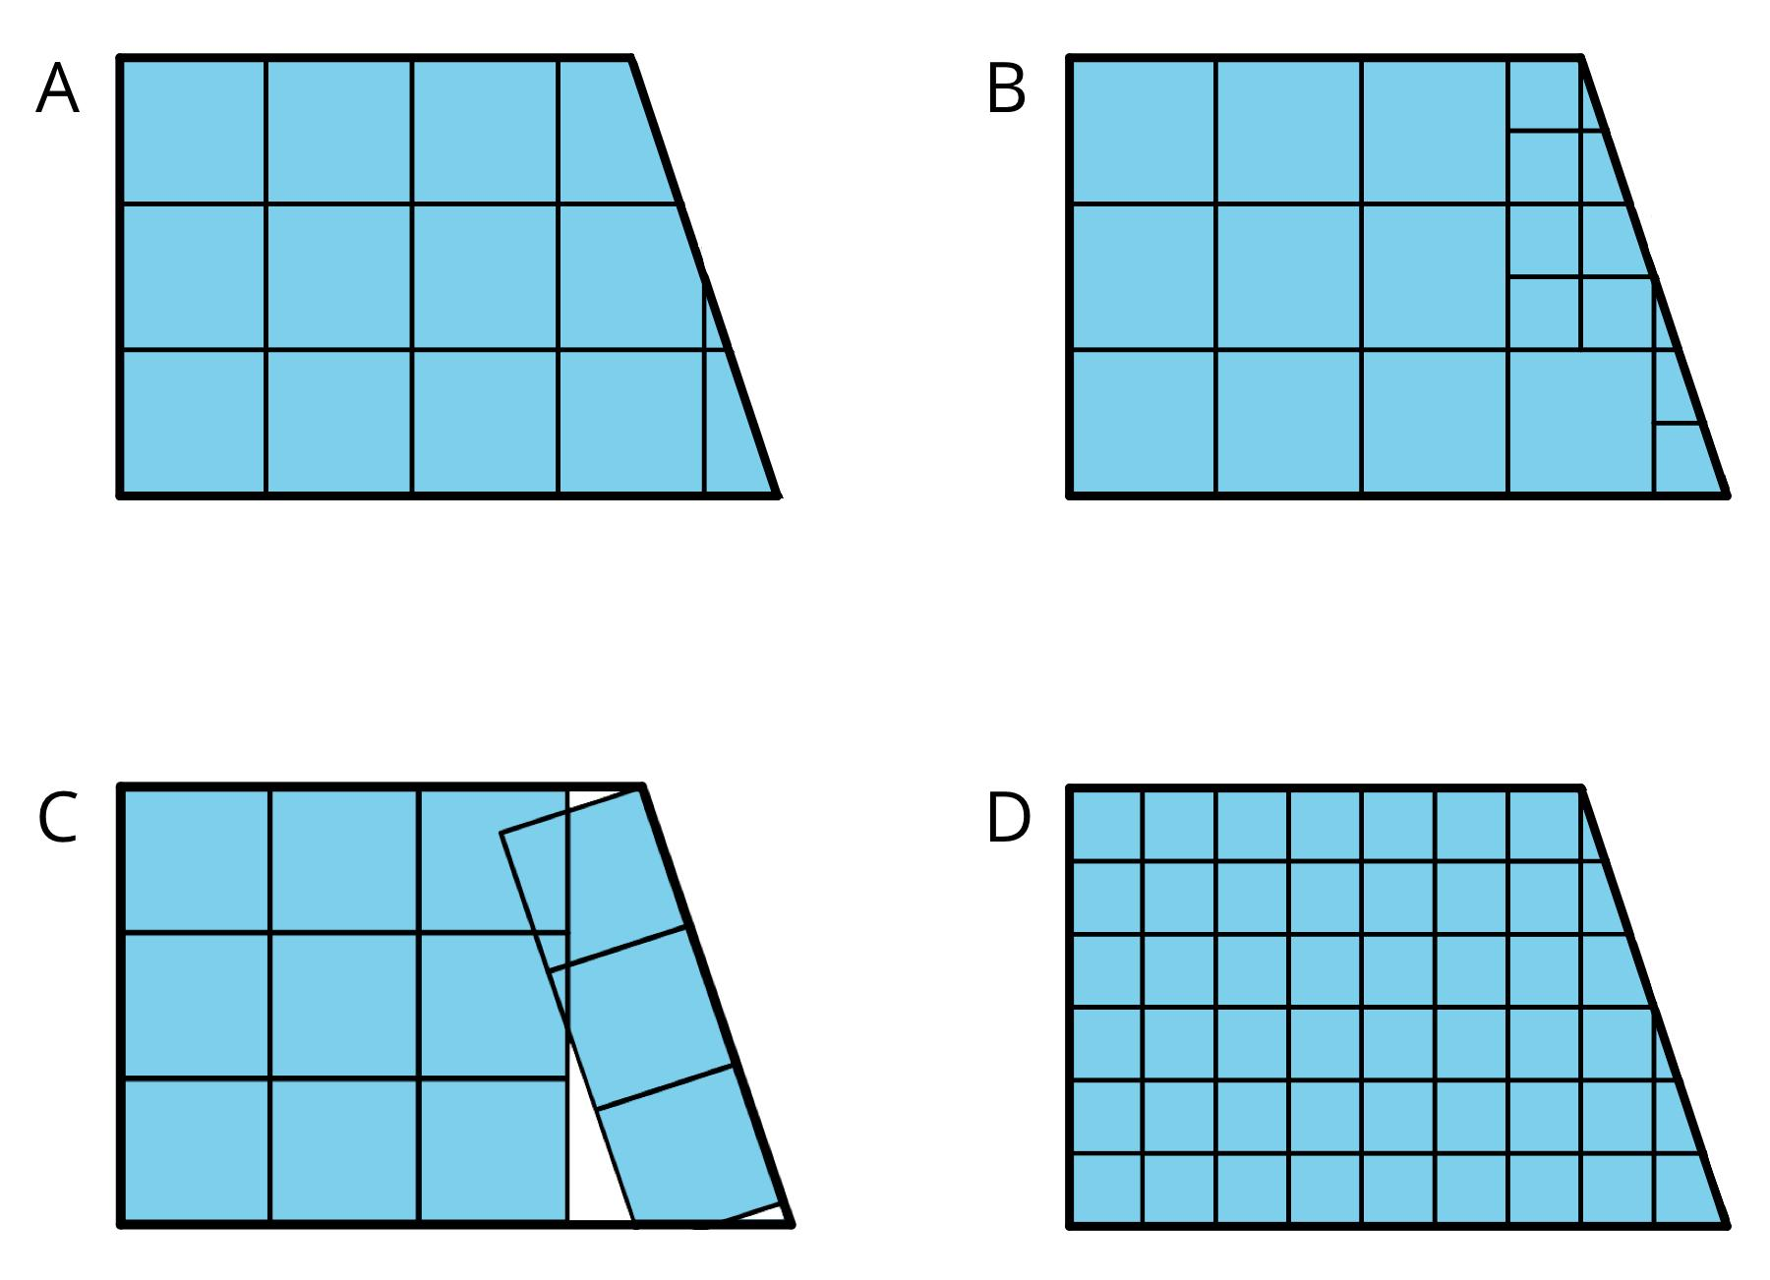
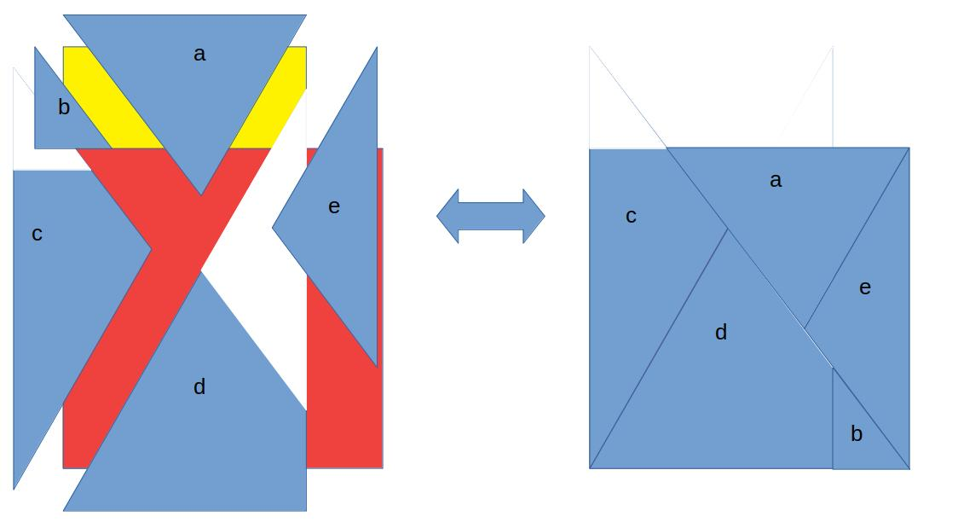
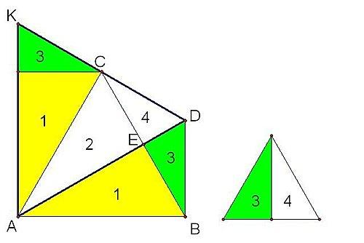
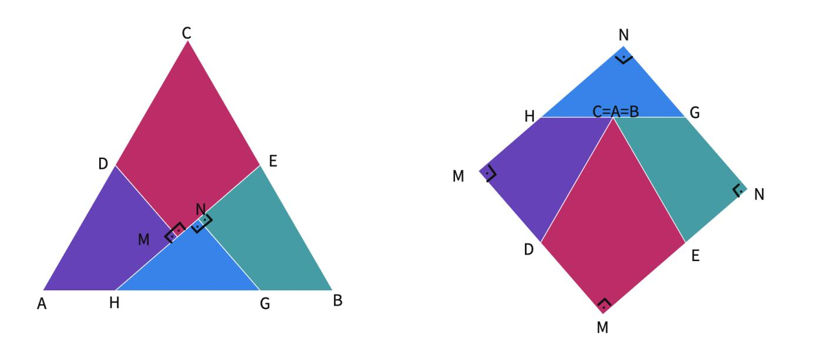
Definition
A figure can be divided into smaller regions whose areas can be compared with another figure.
If:
$$A=A_{1}+A_{2}+A_{3}$$
and another figure satisfies:
$$B=A_{1}+A_{2}+A_{3}$$
then:
$$\boxed{A=B}$$
Example
Suppose a large rectangle is divided into two triangles:
$$A_{\text{rectangle}}=A_{△1}+A_{△2}$$
If another figure consists of exactly those same two component areas, then:
$$\boxed{A_{\text{rectangle}}=A_{\text{other figure}}}$$
Key Idea
$$\boxed{\text{Break a figure into parts}→\text{Compare the parts}}$$

Equality from Rearrangement
# Source: AI Source: Provided by: [Data Path: Persons Table -> ID Column: 1, Name_En Column: Motasem Essam] -> From: [ChatGPT] on [7/25/2026]
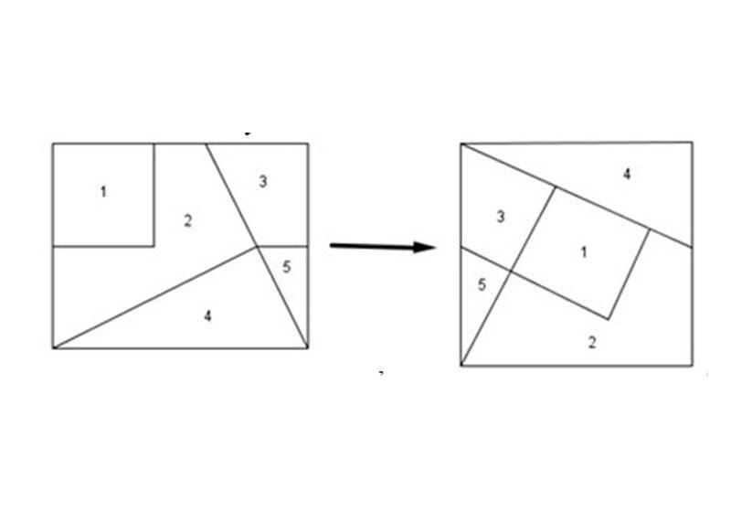
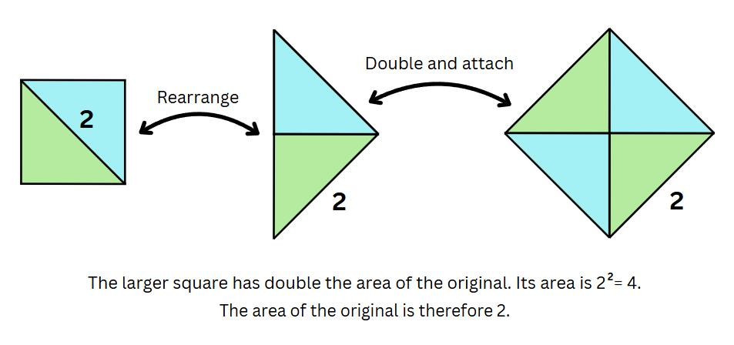
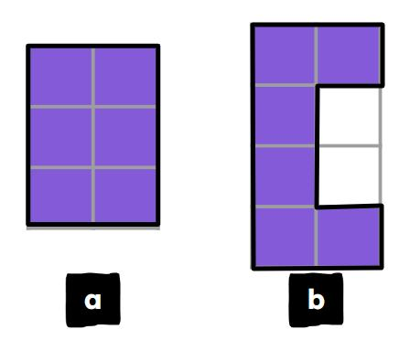
A figure can sometimes be cut into pieces and rearranged without changing the total area.
If pieces are rearranged:
$$P_{1},P_{2},…,P_{n}$$
without overlapping or leaving gaps, then:
$$\boxed{A_{\text{before}}=A_{\text{after}}}$$
Example
A parallelogram can be rearranged into a rectangle with the same base and height.
Therefore:
$$\boxed{A_{\text{parallelogram}}=A_{\text{rectangle}}}$$
and both have:
$$\boxed{A=bh}$$

9. Equality from Base-and-Height Relationships
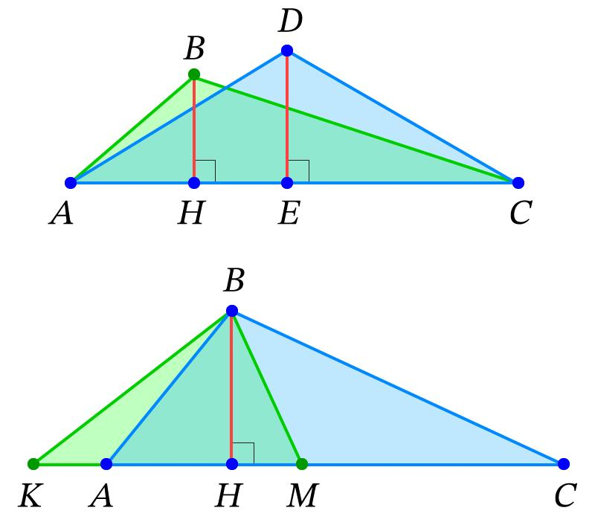
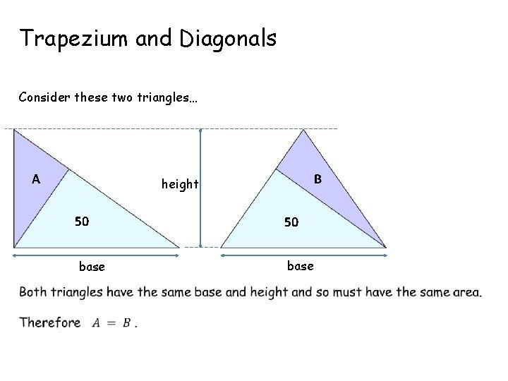
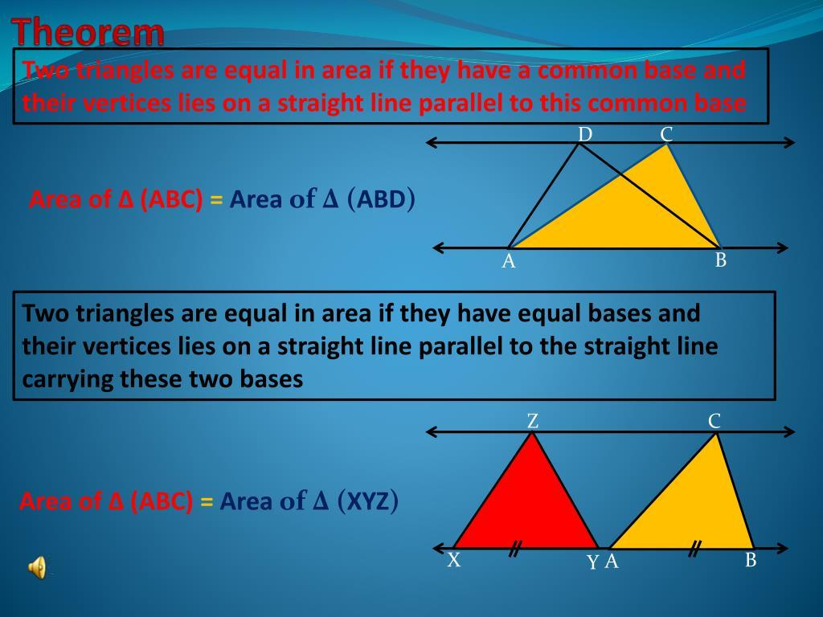
One of the most important area-equality principles is:
Figures with equal bases and equal corresponding heights have equal areas.
For triangles:
$$A=\frac{1}{2}bh$$
Therefore, if two triangles have:
$$b_{1}=b_{2}$$
and:
$$h_{1}=h_{2}$$
then:
$$\boxed{A_{1}=A_{2}}$$
Example
Triangle 1:
$$b=10, h=6$$
Triangle 2:
$$b=10, h=6$$
Then:
$$A_{1}=\frac{1}{2}\left(10\right)\left(6\right)=30 \\ A_{2}=\frac{1}{2}\left(10\right)\left(6\right)=30$$
Therefore:
$$\boxed{A_{1}=A_{2}=30{\text{ cm}}^{2}}$$

Equal-Area Triangles on the Same Base
# Source: AI Source: Provided by: [Data Path: Persons Table -> ID Column: 1, Name_En Column: Motasem Essam] -> From: [ChatGPT] on [7/25/2026]
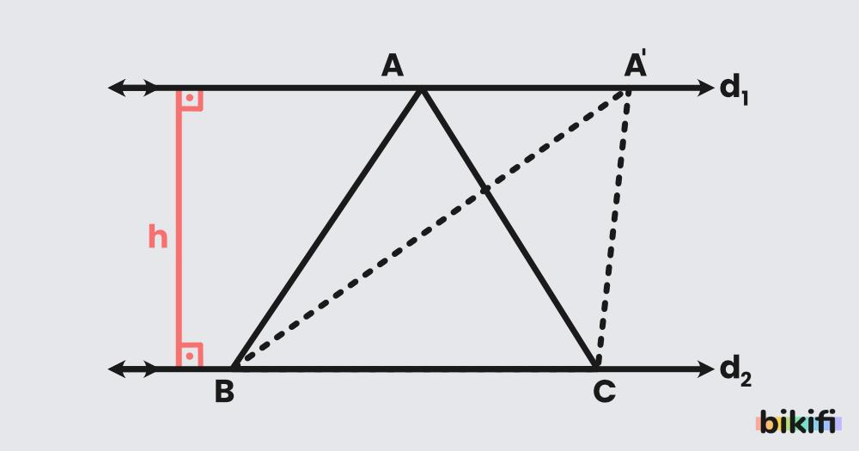
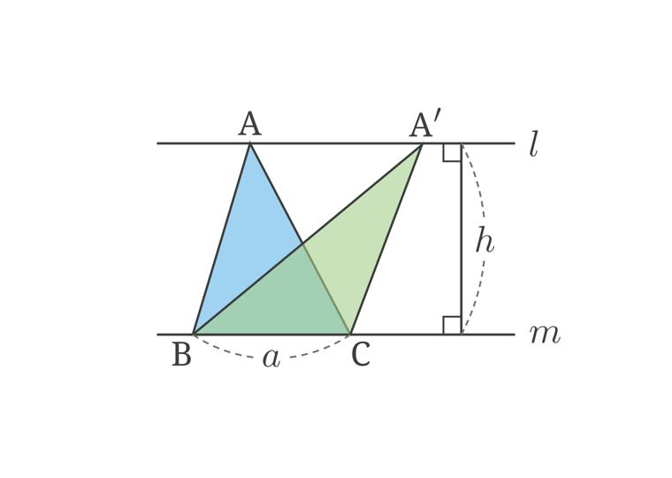
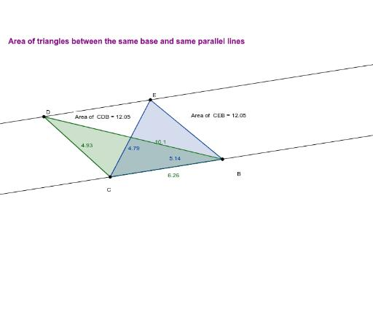
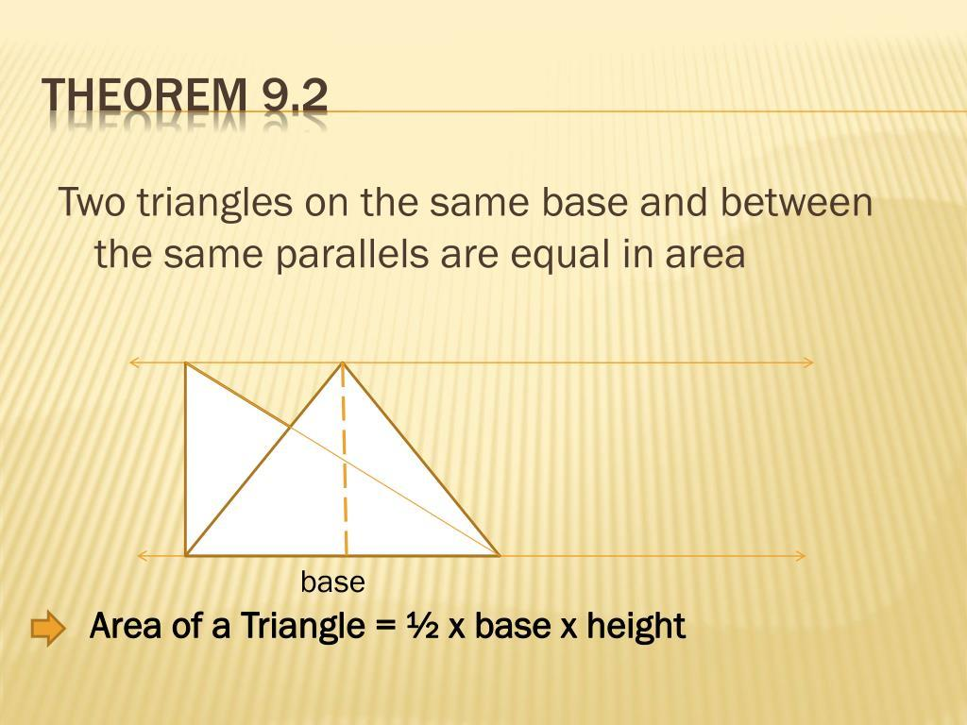
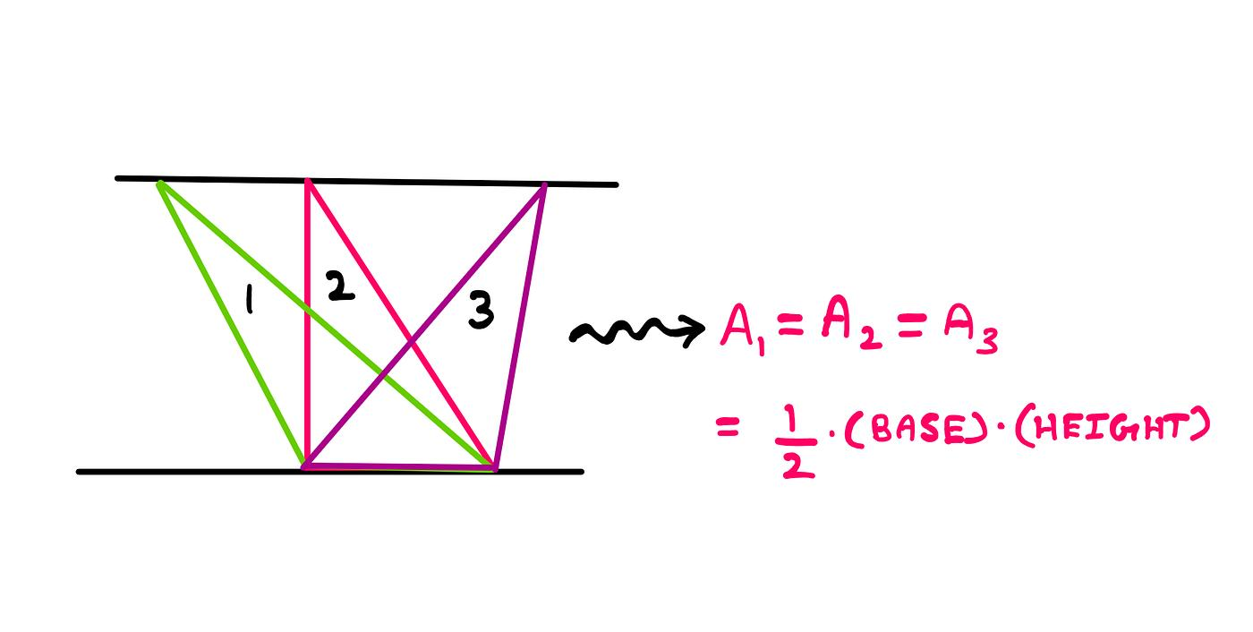
If two triangles share the same base and their third vertices lie on a line parallel to that base, their heights are equal.
Therefore:
$$\boxed{A_{1}=A_{2}}$$
Example
Triangles $ABC$and $ABD$share base $AB$.
If $C$and $D$lie on a line parallel to $AB$, then:
$$h_{C}=h_{D}$$
and therefore:
$$\frac{1}{2}\left(AB\right)\left(h_{C}\right)=\frac{1}{2}\left(AB\right)\left(h_{D}\right)$$
so:
$$\boxed{\left[ABC\right]=\left[ABD\right]}$$
where $\left[ABC\right]$denotes the area of triangle $ABC$.

Equality from Parallelograms
# Source: AI Source: Provided by: [Data Path: Persons Table -> ID Column: 1, Name_En Column: Motasem Essam] -> From: [ChatGPT] on [7/25/2026]
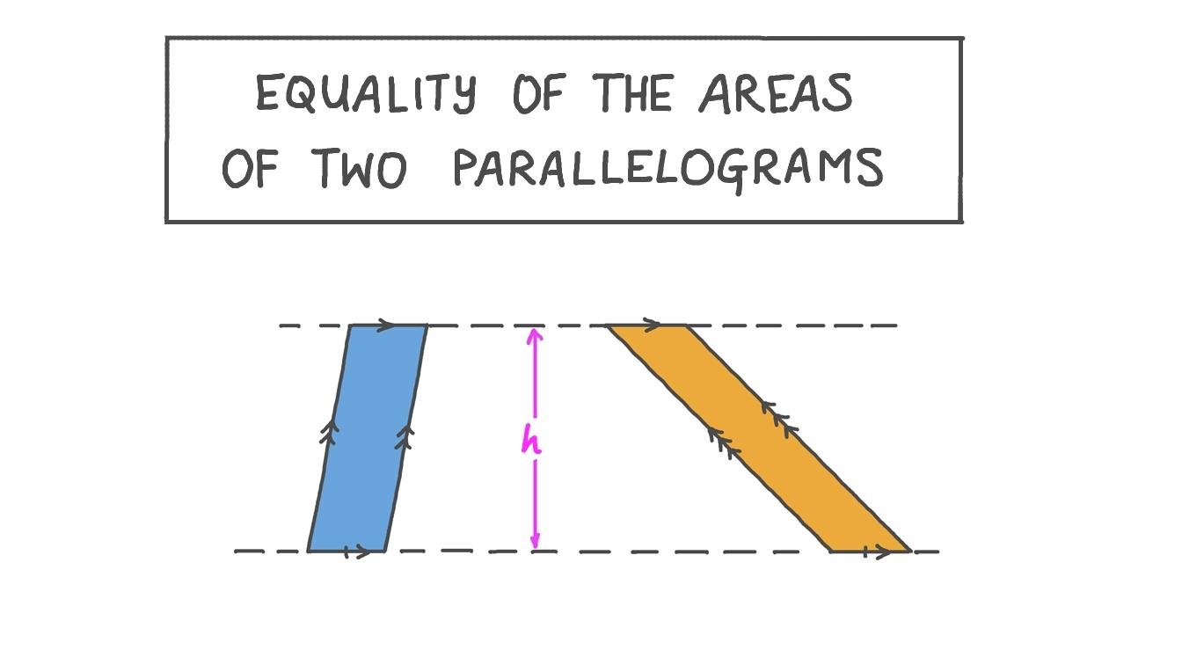
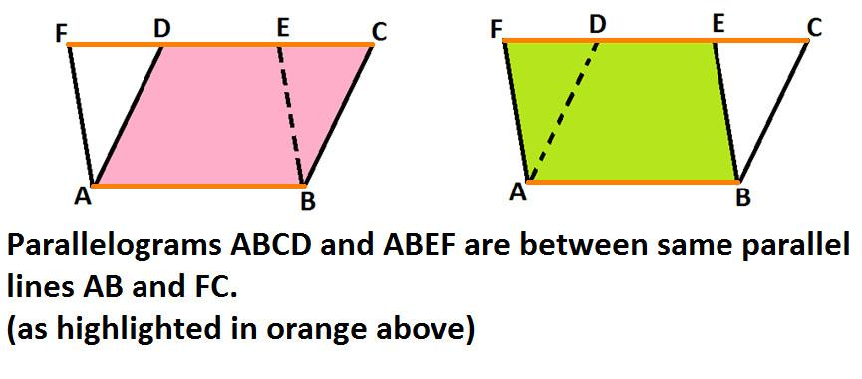
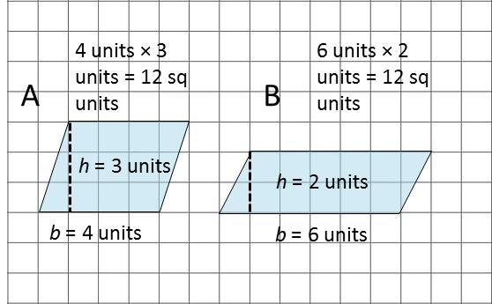
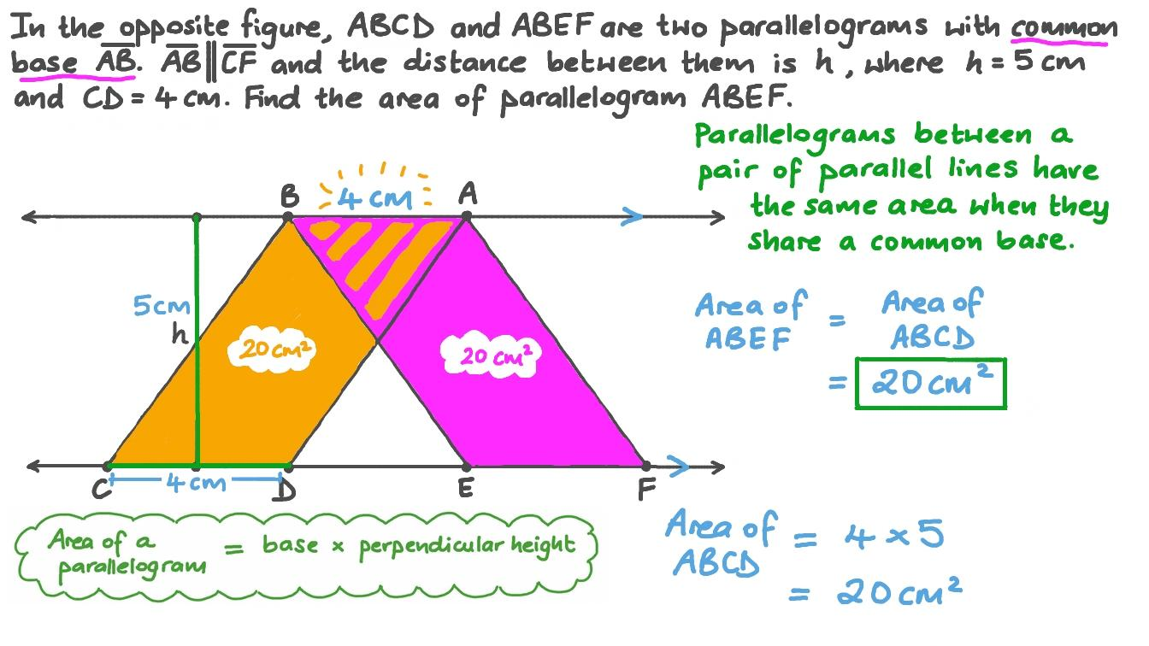
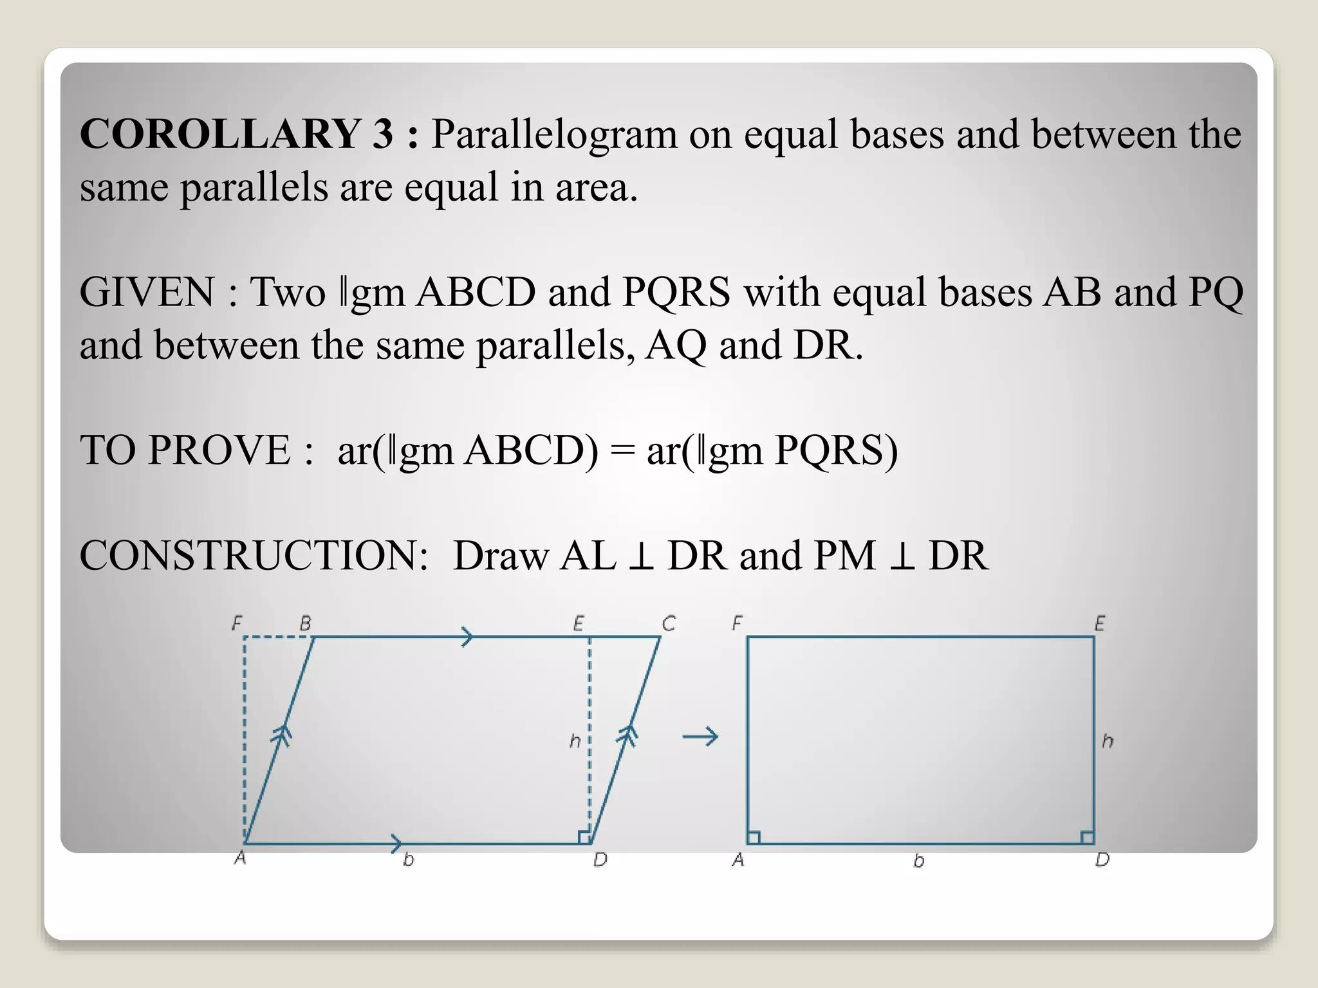
The area of a parallelogram is:
$$\boxed{A=bh}$$
Therefore, parallelograms with equal bases and equal heights have equal areas.
Example
Parallelogram 1:
$$b=8, h=5$$
Parallelogram 2:
$$b=8, h=5$$
Then:
$$A_{1}=8\left(5\right)=40 \\ A_{2}=8\left(5\right)=40$$
Therefore:
$$\boxed{A_{1}=A_{2}=40{\text{ cm}}^{2}}$$

Equality from Congruent Triangles
# Source: AI Source: Provided by: [Data Path: Persons Table -> ID Column: 1, Name_En Column: Motasem Essam] -> From: [ChatGPT] on [7/25/2026]
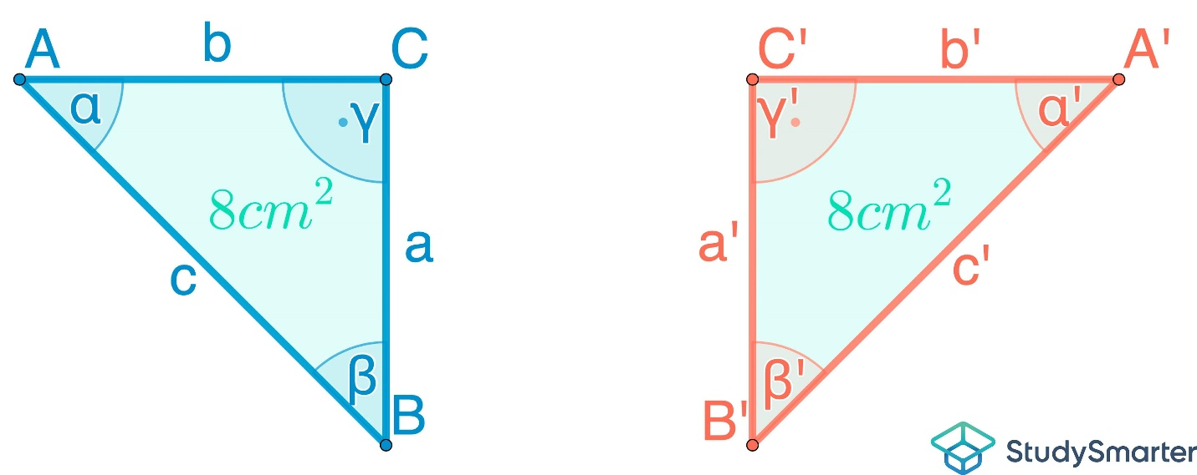
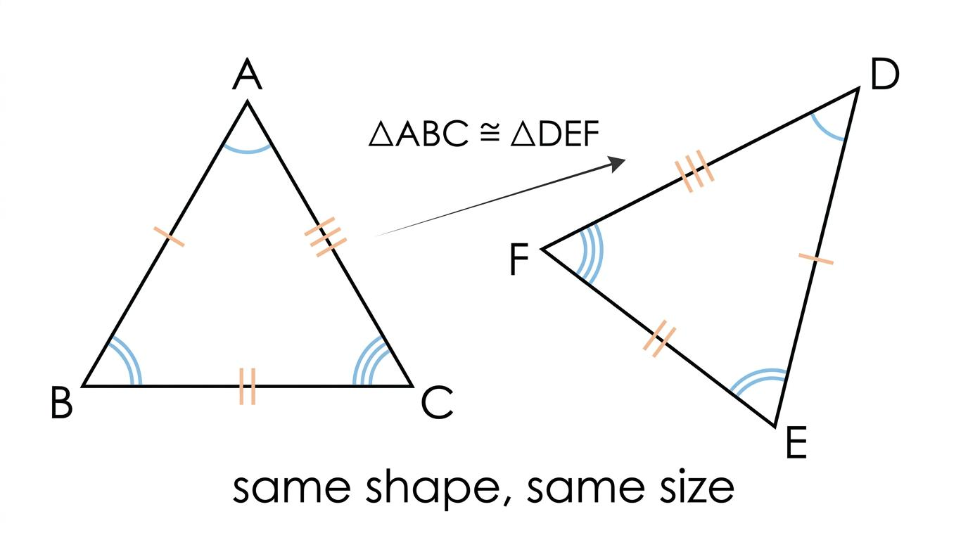
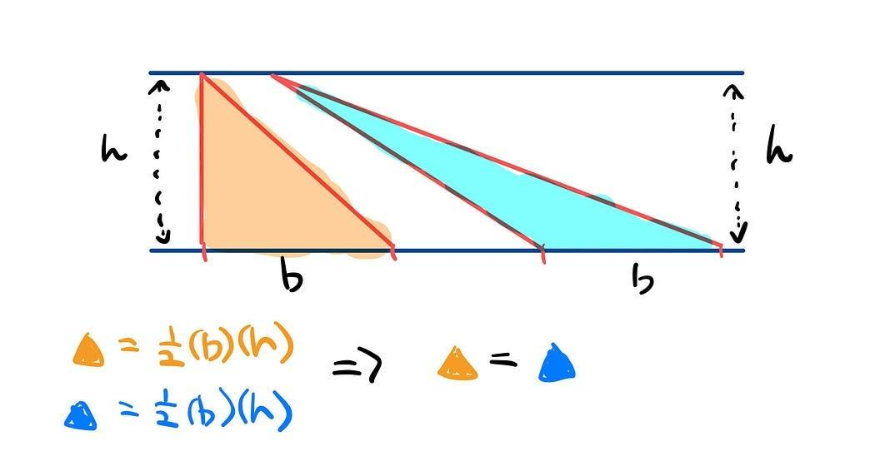
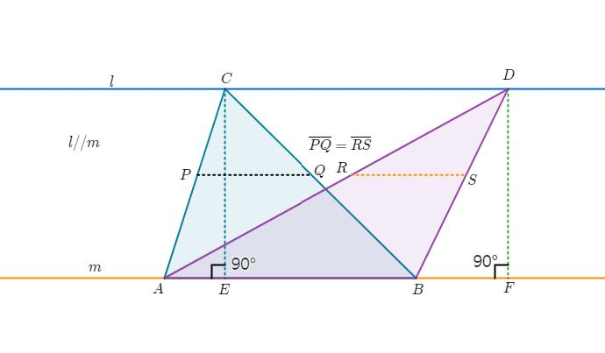
If two triangles are congruent:
$$△ABC≅△DEF$$
then they have equal areas:
$$\boxed{\left[ABC\right]=\left[DEF\right]}$$
Example
If each congruent triangle has:
$$b=10\text{ cm}, h=6\text{ cm}$$
then:
$$\left[ABC\right]=\left[DEF\right]=\frac{1}{2}\left(10\right)\left(6\right) \\ \boxed{\left[ABC\right]=\left[DEF\right]=30{\text{ cm}}^{2}}$$

Equality from Symmetry
# Source: AI Source: Provided by: [Data Path: Persons Table -> ID Column: 1, Name_En Column: Motasem Essam] -> From: [ChatGPT] on [7/25/2026]
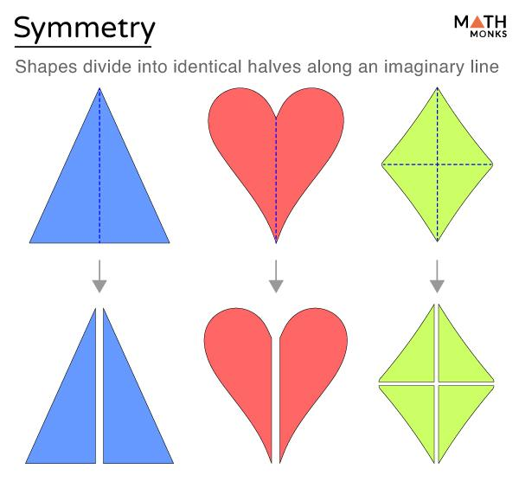
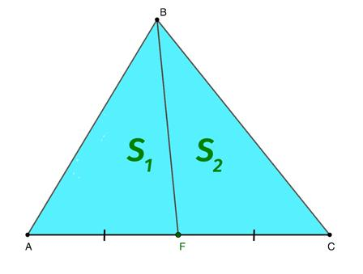
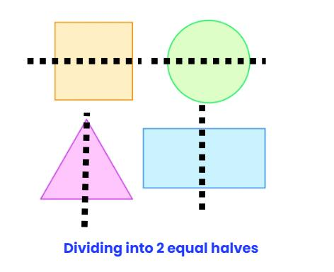
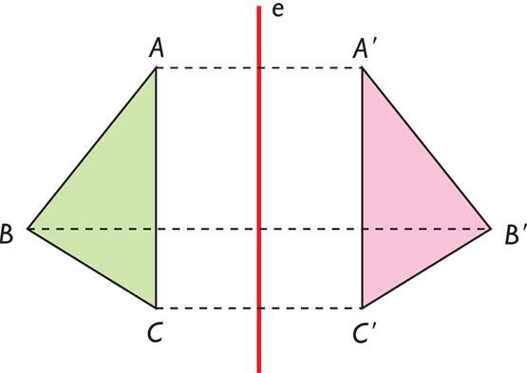
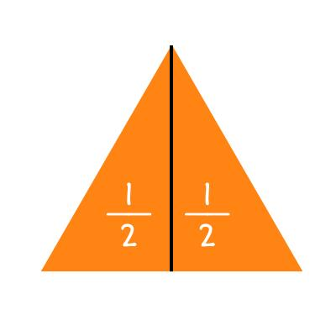
A line of symmetry can divide a figure into two regions with equal area.
If line $l$is an axis of symmetry:
$$\boxed{A_{1}=A_{2}}$$
Example
A rectangle divided through its center by a vertical symmetry axis produces two equal rectangles.
If the original rectangle has:
$$A=40{\text{ cm}}^{2}$$
then each half has:
$$\boxed{A_{1}=A_{2}=20{\text{ cm}}^{2}}$$
Important
Symmetry is not required for two regions to have equal area, but symmetry is a common way to establish it.

Equality from Transformations
# Source: AI Source: Provided by: [Data Path: Persons Table -> ID Column: 1, Name_En Column: Motasem Essam] -> From: [ChatGPT] on [7/25/2026]
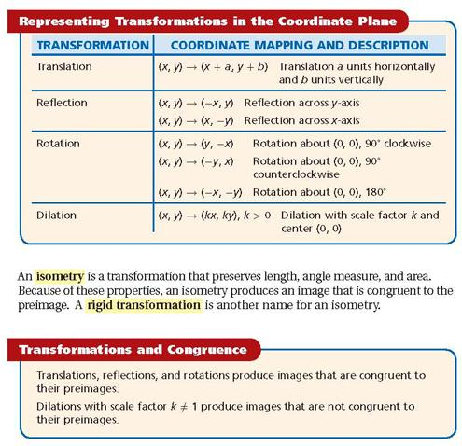
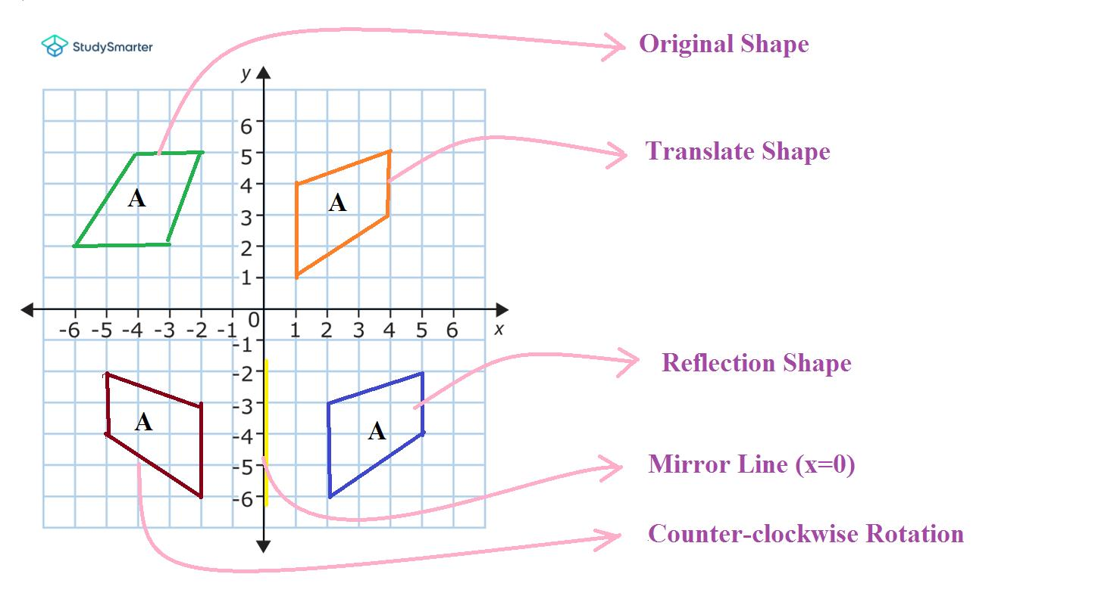
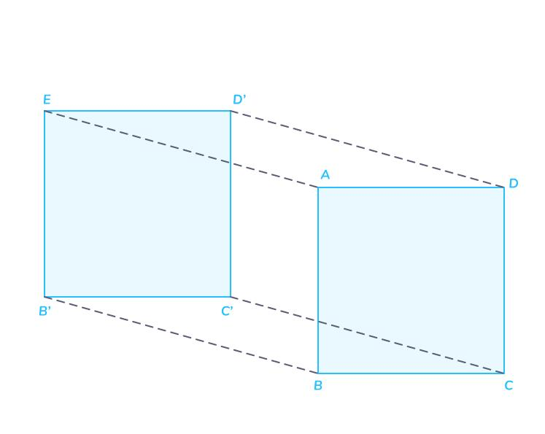
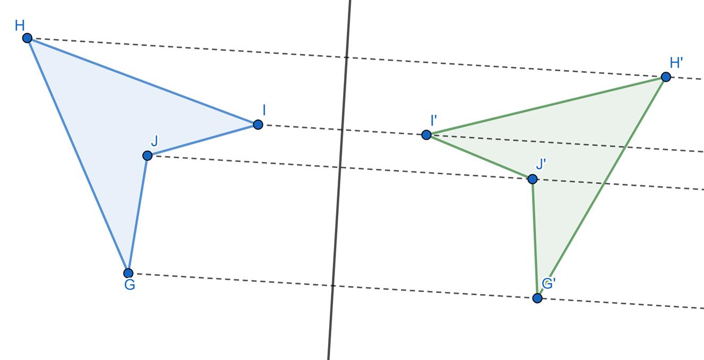
Rigid transformations preserve area.
These include:
- translation,
- rotation,
- reflection,
- glide reflection.
If a figure $F$is transformed by an isometry into $F^{'}$, then:
$$\boxed{A\left(F\right)=A\left(F^{'}\right)}$$
Example
A triangle with area:
$$30{\text{ cm}}^{2}$$
is rotated.
Its image still has:
$$\boxed{30{\text{ cm}}^{2}}$$

Equality from Scaling
# Source: AI Source: Provided by: [Data Path: Persons Table -> ID Column: 1, Name_En Column: Motasem Essam] -> From: [ChatGPT] on [7/25/2026]
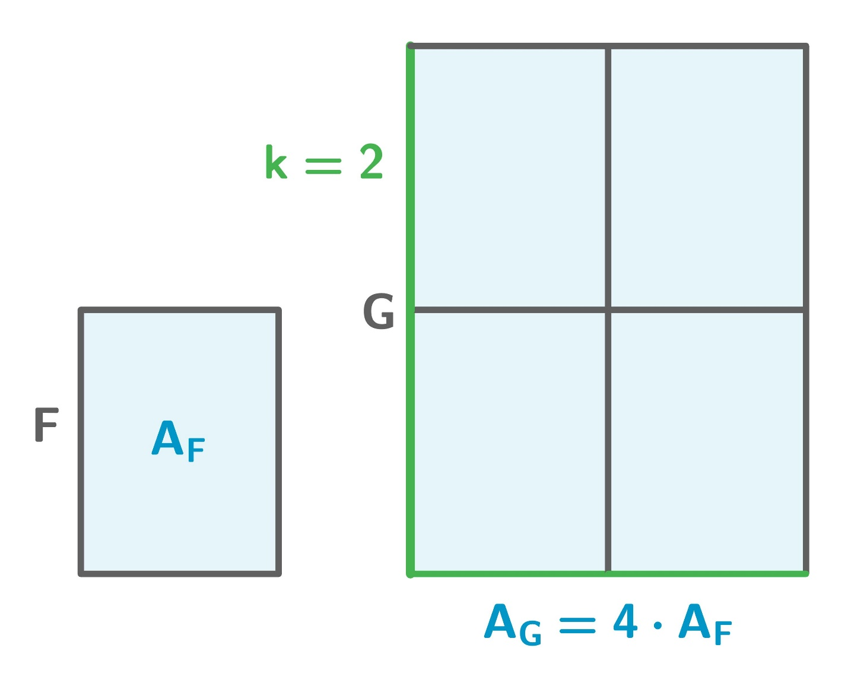
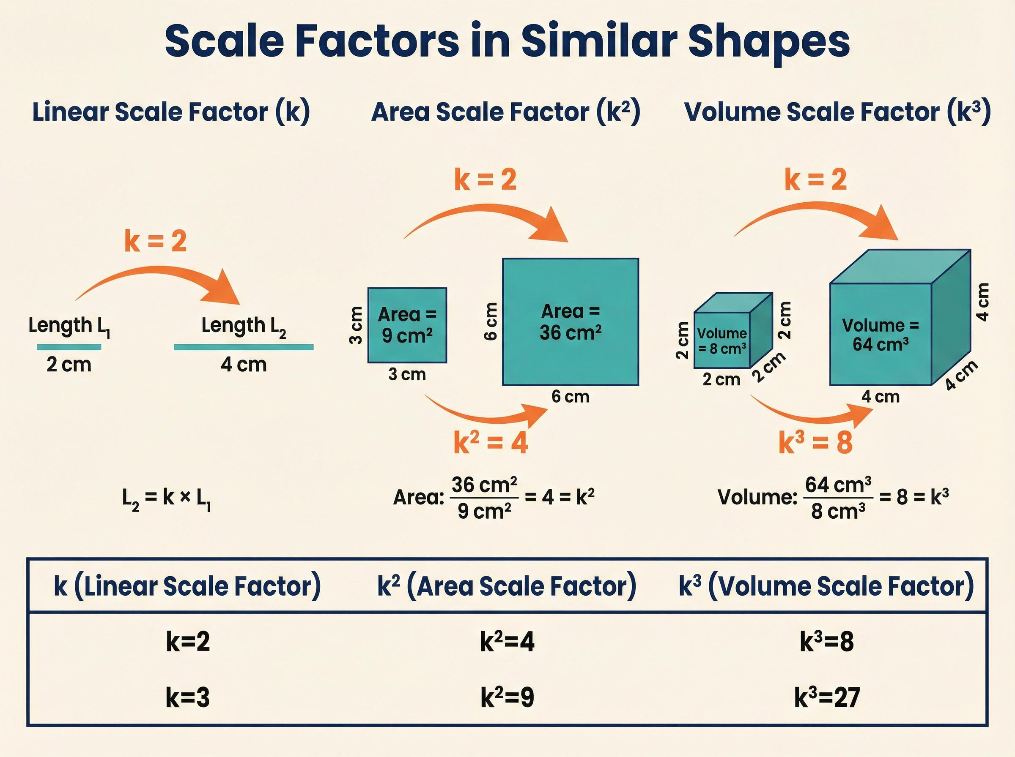
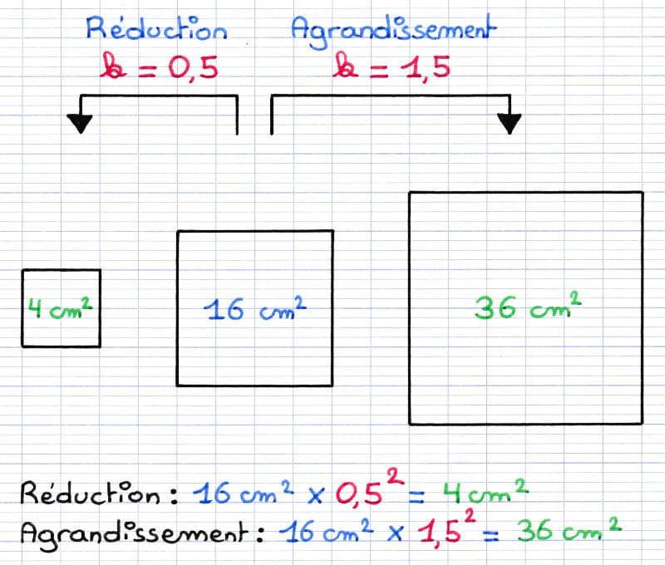
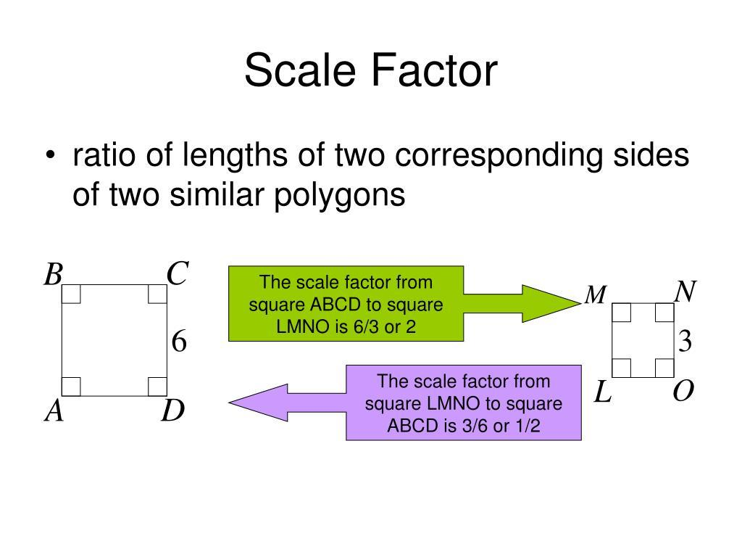
Scaling normally changes area.
If the linear scale factor is $k$, then:
$$\boxed{A^{'}=k^{2}A}$$
Therefore, two similar figures have equal areas only when:
$$k^{2}=1$$
For positive lengths:
$$\boxed{k=1}$$
Example
If a triangle has area:
$$20{\text{ cm}}^{2}$$
and is scaled by:
$$k=2$$
then:
$$A^{'}=2^{2}\left(20\right) \\ \boxed{A^{'}=80{\text{ cm}}^{2}}$$
So the areas are not equal.
Important
$$\boxed{\text{Similarity}⇏\text{Equal Area}}$$
unless the scale factor is $1$.

Equality from Circle Relationships
# Source: AI Source: Provided by: [Data Path: Persons Table -> ID Column: 1, Name_En Column: Motasem Essam] -> From: [ChatGPT] on [7/25/2026]
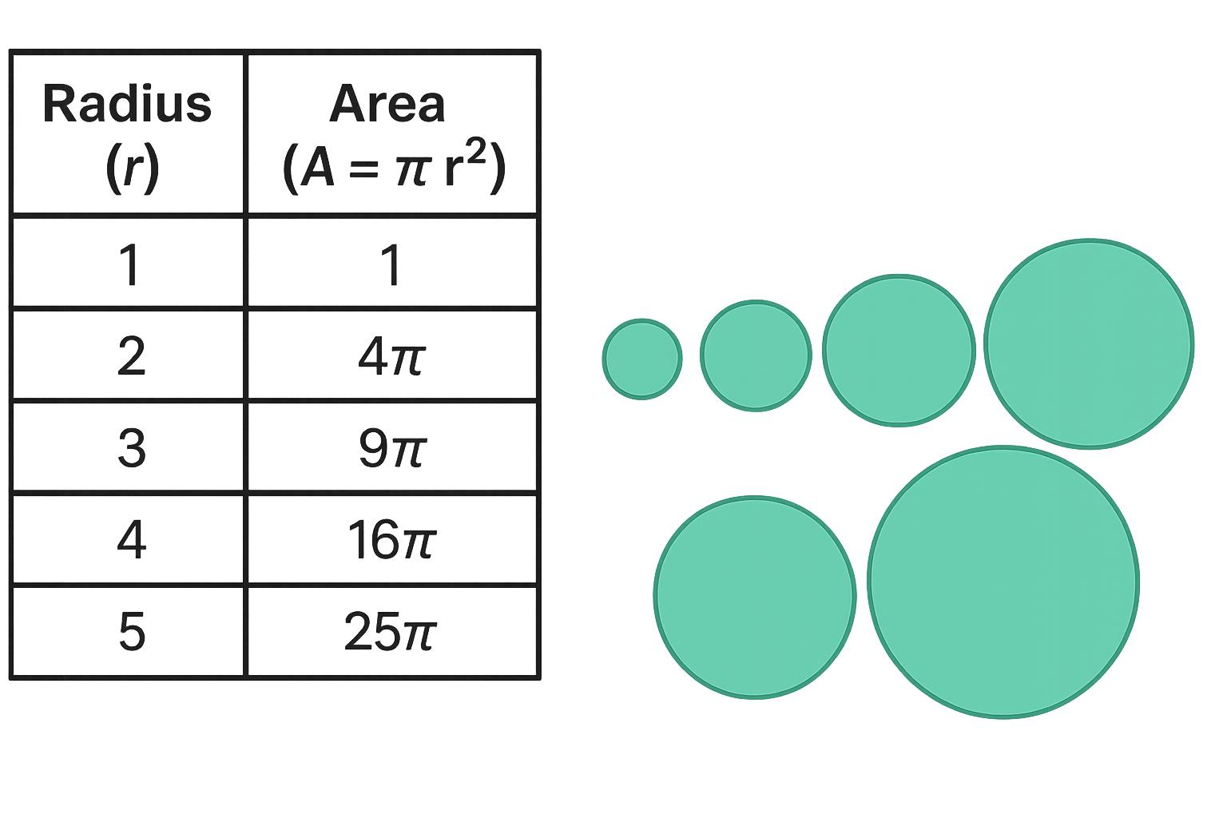
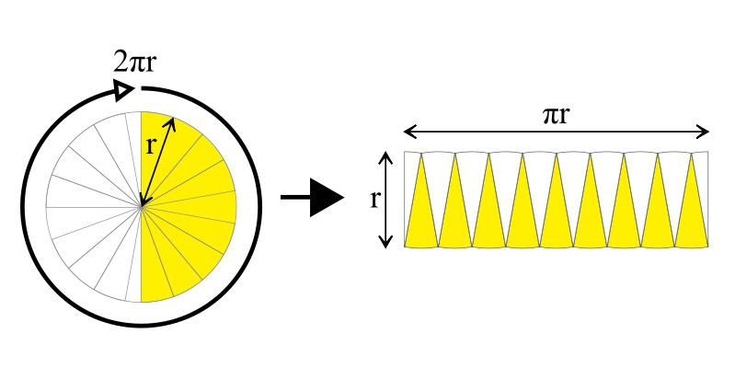
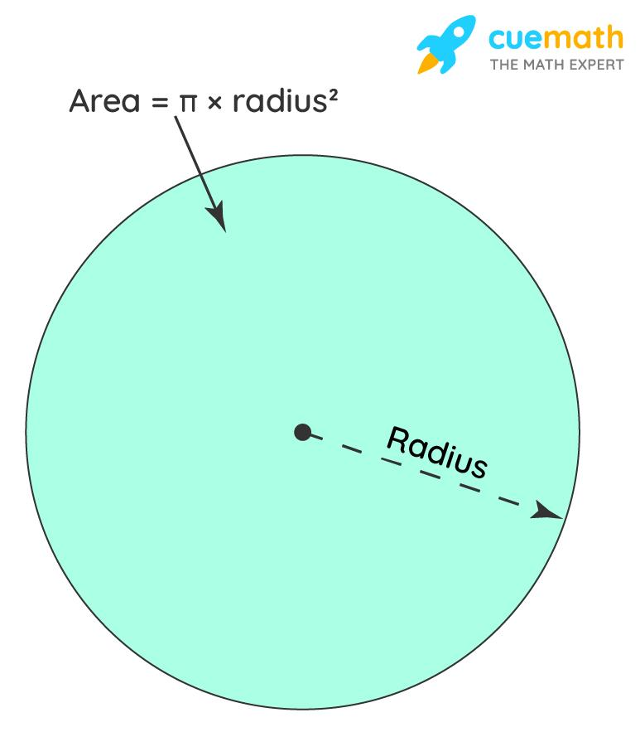
The area of a circle is:
$$\boxed{A=πr^{2}}$$
Therefore, circles with equal radii have equal areas.
If:
$$r_{1}=r_{2}$$
then:
$$\boxed{A_{1}=A_{2}}$$
Example
If:
$$r_{1}=r_{2}=5\text{ cm}$$
then:
$$A_{1}=A_{2}=π{\left(5\right)}^{2} \\ \boxed{A_{1}=A_{2}=25π{\text{ cm}}^{2}}$$

Equality from Equal Areas of Circular Regions
# Source: AI Source: Provided by: [Data Path: Persons Table -> ID Column: 1, Name_En Column: Motasem Essam] -> From: [ChatGPT] on [7/25/2026]
Equal areas can also occur between different circular regions.
For two circles:
$$πr_{1}^{2}=πr_{2}^{2}$$
so:
$$r_{1}^{2}=r_{2}^{2}$$
For positive radii:
$$\boxed{r_{1}=r_{2}}$$
Thus, two full circles have equal area exactly when their radii are equal.

Equality from Coordinate Geometry
# Source: AI Source: Provided by: [Data Path: Persons Table -> ID Column: 1, Name_En Column: Motasem Essam] -> From: [ChatGPT] on [7/25/2026]
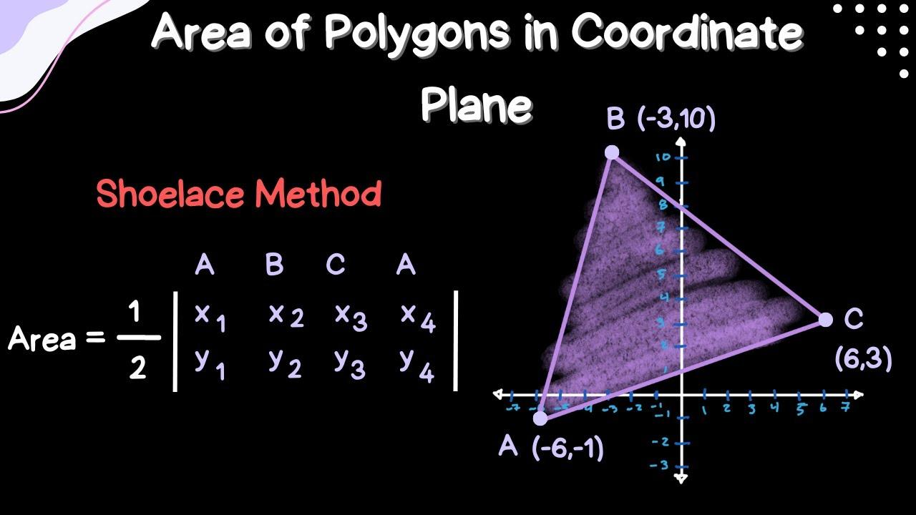
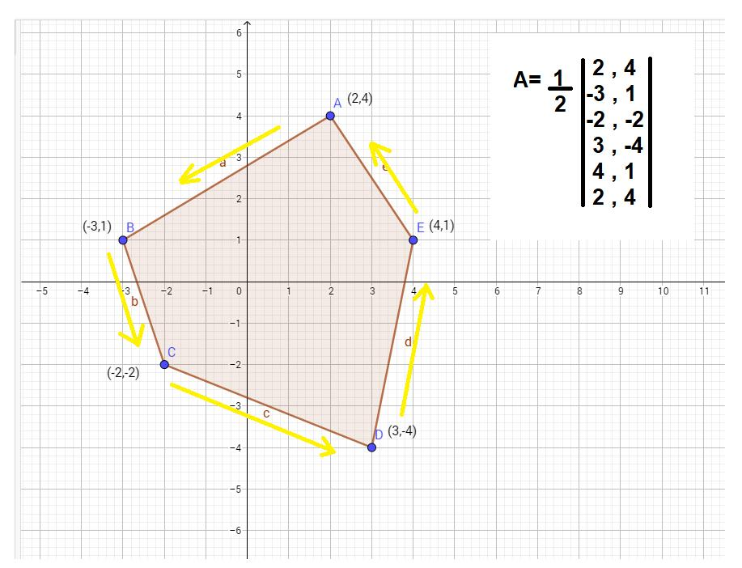
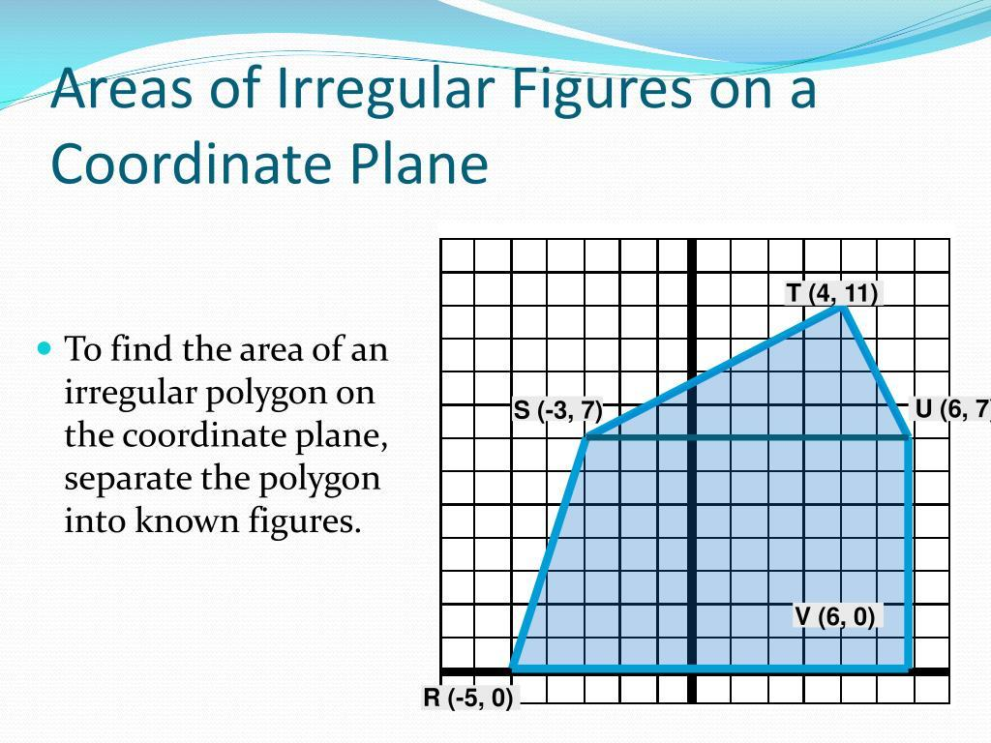
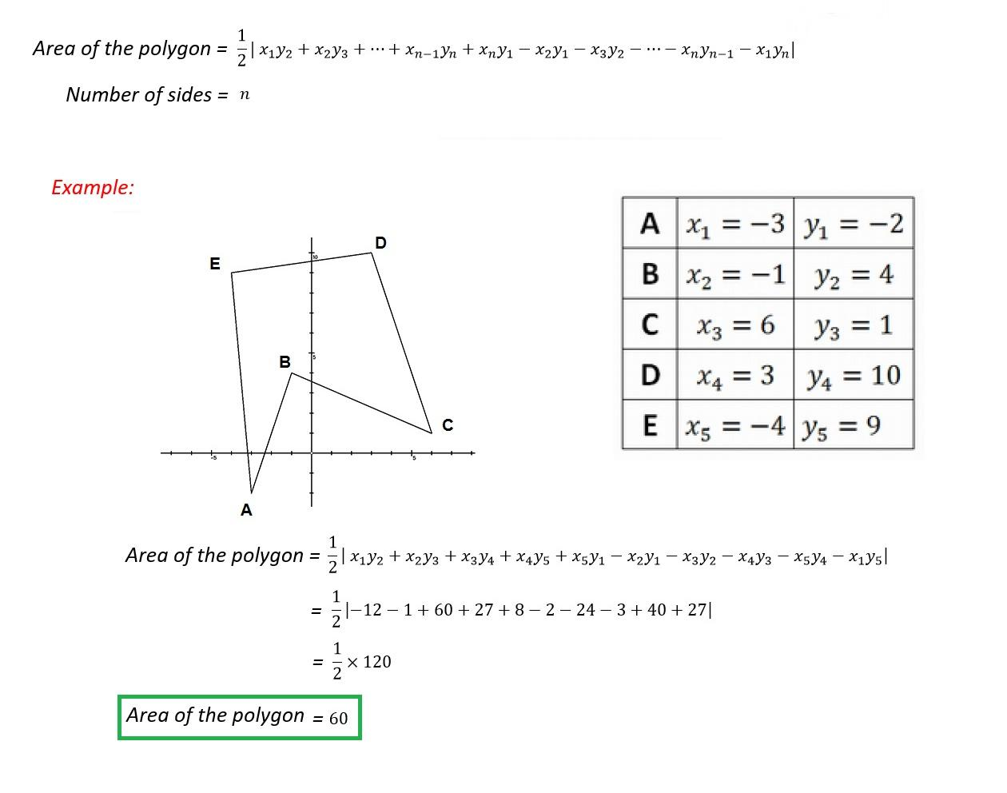
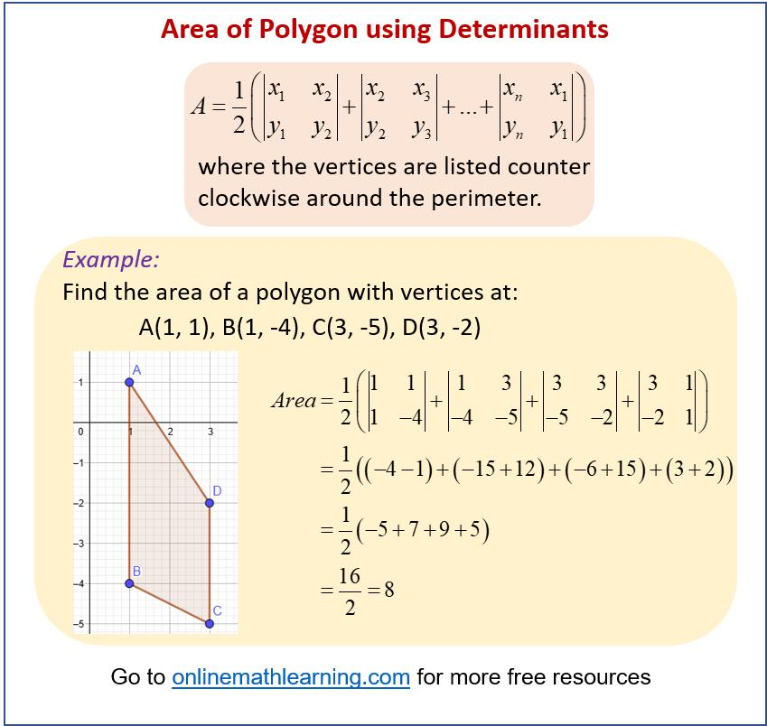
Coordinates can be used to calculate and compare areas.
For a polygon with vertices:
$$\left(x_{1} , y_{1}\right),\left(x_{2} , y_{2}\right),…,\left(x_{n} , y_{n}\right)$$
the shoelace formula is:
$$\boxed{A=\frac{1}{2}∣\sum_{i=1}^{n}{(}\left.x_{i}y_{i+1}-y_{i}x_{i+1}\right)∣}$$
with cyclic indexing.
Example
Suppose two polygons are calculated to have:
$$A_{1}=36$$
and:
$$A_{2}=36$$
Then:
$$\boxed{A_{1}=A_{2}}$$
Coordinate geometry therefore provides a computational method for proving or verifying area equality.

Equality Established Algebraically
# Source: AI Source: Provided by: [Data Path: Persons Table -> ID Column: 1, Name_En Column: Motasem Essam] -> From: [ChatGPT] on [7/25/2026]
Area equality can be established by solving equations.
Example
Suppose:
$$A_{1}=3x+8$$
and:
$$A_{2}=5x-12$$
If:
$$A_{1}=A_{2}$$
then:
$$3x+8=5x-12 \\ 20=2x \\ x=10$$
Therefore:
$$A_{1}=3\left(10\right)+8=38$$
and:
$$A_{2}=5\left(10\right)-12=38$$
Thus:
$$\boxed{A_{1}=A_{2}=38}$$

Equal-Area Rectangle and Triangle
# Source: AI Source: Provided by: [Data Path: Persons Table -> ID Column: 1, Name_En Column: Motasem Essam] -> From: [ChatGPT] on [7/25/2026]
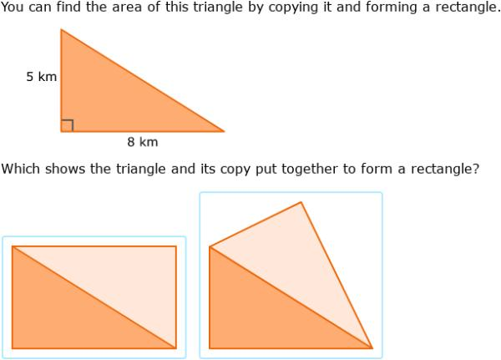
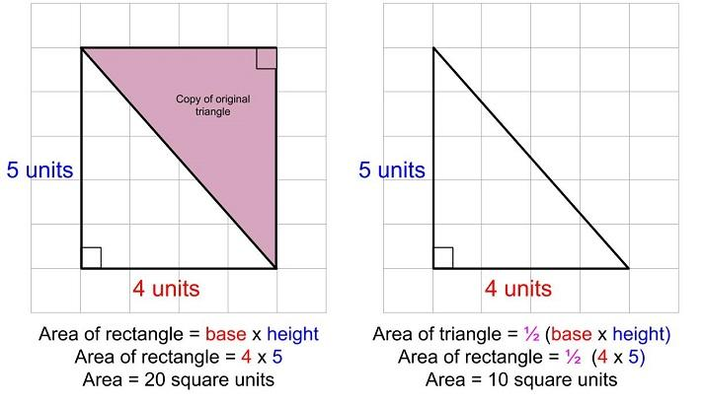
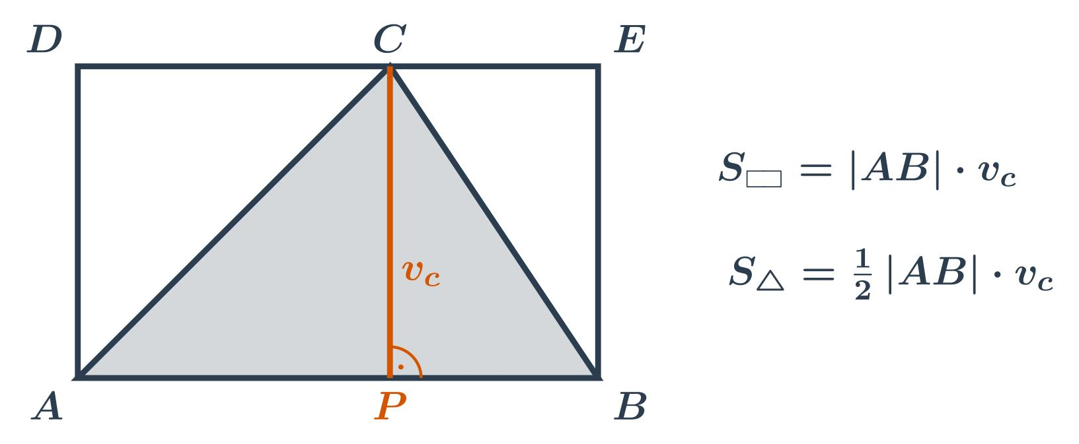
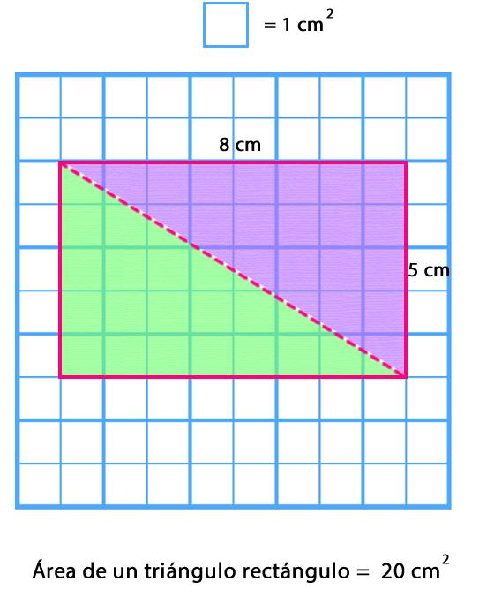
Different shapes can have exactly the same area.
Suppose a rectangle has:
$$b=6, h=4$$
Then:
$$A_{\text{rectangle}}=6\left(4\right)=24$$
Now consider a triangle with:
$$b=8, h=6$$
Then:
$$A_{\text{triangle}}=\frac{1}{2}\left(8\right)\left(6\right)=24$$
Therefore:
$$\boxed{A_{\text{rectangle}}=A_{\text{triangle}}=24{\text{ cm}}^{2}}$$
The figures are not congruent, but their areas are equal.

Equal-Area Parallelogram and Rectangle
# Source: AI Source: Provided by: [Data Path: Persons Table -> ID Column: 1, Name_En Column: Motasem Essam] -> From: [ChatGPT] on [7/25/2026]
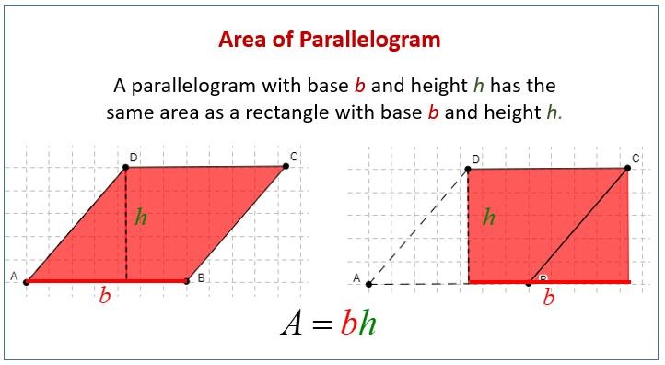
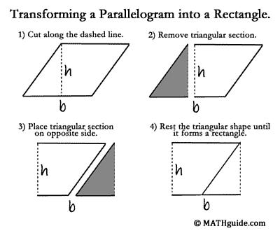
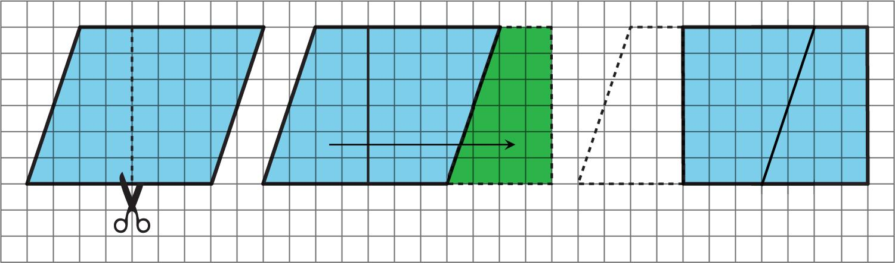
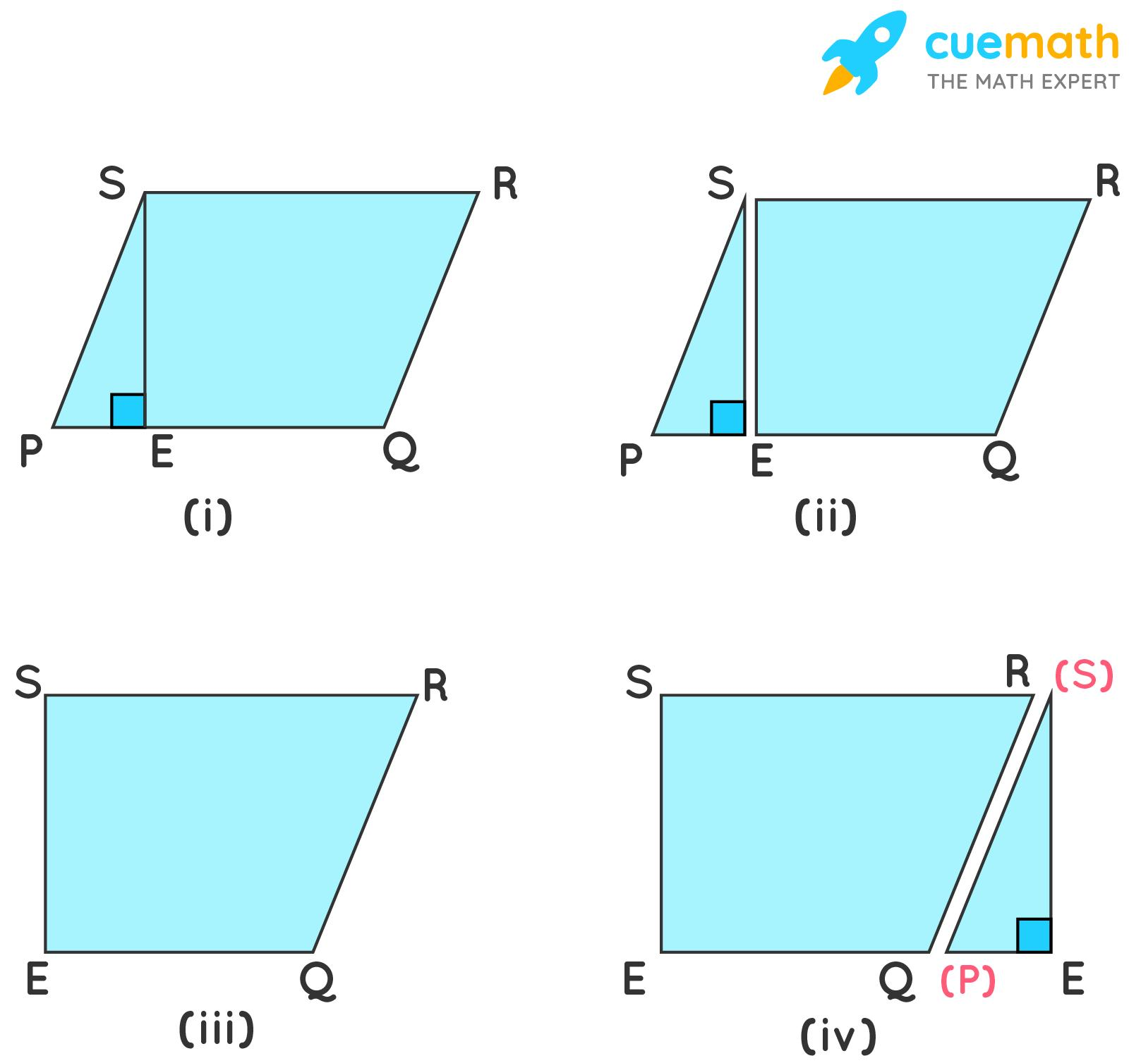
A parallelogram and rectangle with the same base and height have equal areas.
For both:
$$A=bh$$
Example
If:
$$b=10\text{ cm}, h=4\text{ cm}$$
then:
$$A_{\text{parallelogram}}=10\left(4\right)=40$$
and:
$$A_{\text{rectangle}}=10\left(4\right)=40$$
Therefore:
$$\boxed{A_{\text{parallelogram}}=A_{\text{rectangle}}=40{\text{ cm}}^{2}}$$

Area Equality in Geometric Proofs
# Source: AI Source: Provided by: [Data Path: Persons Table -> ID Column: 1, Name_En Column: Motasem Essam] -> From: [ChatGPT] on [7/25/2026]
Area equality is often used as part of a geometric proof.
Example
Suppose two triangles have:
- the same base,
- vertices on a line parallel to that base.
Then their heights are equal.
Therefore:
$$A_{1}=\frac{1}{2}bh$$
and:
$$A_{2}=\frac{1}{2}bh$$
Thus:
$$\boxed{A_{1}=A_{2}}$$
This area relationship can then be used to prove other geometric properties.

Area Equality vs Congruence
# Source: AI Source: Provided by: [Data Path: Persons Table -> ID Column: 1, Name_En Column: Motasem Essam] -> From: [ChatGPT] on [7/25/2026]
This distinction is extremely important.
Congruence
$$\boxed{F_{1}≅F_{2}}$$
means the figures have the same shape and size.
Therefore:
$$F_{1}≅F_{2}⇒A_{1}=A_{2}$$
Area Equality
$$\boxed{A_{1}=A_{2}}$$
only means the areas are equal.
It does not imply:
$$F_{1}≅F_{2}$$
Example
A $4×6$rectangle has:
$$A=24$$
A triangle with:
$$b=8, h=6$$
also has:
$$A=24$$
but the figures are clearly not congruent.
Therefore:
$$\boxed{\text{Congruence}⇒\text{Area Equality}}$$
but:
$$\boxed{\text{Area Equality}⇏\text{Congruence}}$$

Area Equality vs Similarity
# Source: AI Source: Provided by: [Data Path: Persons Table -> ID Column: 1, Name_En Column: Motasem Essam] -> From: [ChatGPT] on [7/25/2026]
Similarity means same shape but potentially different size.
If the linear scale factor is $k$:
$$\boxed{A_{2}=k^{2}A_{1}}$$
Therefore:
$$\boxed{A_{1}=A_{2}}$$
only when:
$$\boxed{k=1}$$
for ordinary positive-scale geometry.
So:
$$\boxed{\text{Similarity}⇏\text{Area Equality}}$$

Area Equality vs Area Approximation
# Source: AI Source: Provided by: [Data Path: Persons Table -> ID Column: 1, Name_En Column: Motasem Essam] -> From: [ChatGPT] on [7/25/2026]
Exact Equality
$$\boxed{A_{1}=A_{2}}$$
means the areas are exactly equal.
Approximation
$$\boxed{A_{1}≈A_{2}}$$
means they are approximately equal.
These are mathematically different statements.

Important Area Formulas
# Source: AI Source: Provided by: [Data Path: Persons Table -> ID Column: 1, Name_En Column: Motasem Essam] -> From: [ChatGPT] on [7/25/2026]
Rectangle
$$\boxed{A=bh}$$
Square
$$\boxed{A=s^{2}}$$
Triangle
$$\boxed{A=\frac{1}{2}bh}$$
Parallelogram
$$\boxed{A=bh}$$
Trapezoid
$$\boxed{A=\frac{1}{2}\left(b_{1}+b_{2}\right)h}$$
Circle
$$\boxed{A=πr^{2}}$$
Sector
$$\boxed{A=\frac{1}{2}r^{2}θ}$$
when $θ$is measured in radians.
Ellipse
$$\boxed{A=πab}$$

Important Area-Equality Principles
# Source: AI Source: Provided by: [Data Path: Persons Table -> ID Column: 1, Name_En Column: Motasem Essam] -> From: [ChatGPT] on [7/25/2026]
Congruence
$$\boxed{F_{1}≅F_{2}⇒A_{1}=A_{2}}$$
Same Base and Same Height
For triangles:
$$\boxed{b_{1}=b_{2}, h_{1}=h_{2}⇒A_{1}=A_{2}}$$
Same Base Between Parallel Lines
$$\boxed{A_{1}=A_{2}}$$
for appropriate triangles or parallelograms.
Isometry
$$\boxed{A\left(F\right)=A\left(T\left(F\right)\right)}$$
for an isometry $T$.
Equal Circle Radii
$$\boxed{r_{1}=r_{2}⇒A_{1}=A_{2}}$$
Decomposition
$$\boxed{A=A_{1}+A_{2}+⋯+A_{n}}$$
If another figure has the same component-area sum, its area is equal.

Classification Summary
# Source: AI Source: Provided by: [Data Path: Persons Table -> ID Column: 1, Name_En Column: Motasem Essam] -> From: [ChatGPT] on [7/25/2026]
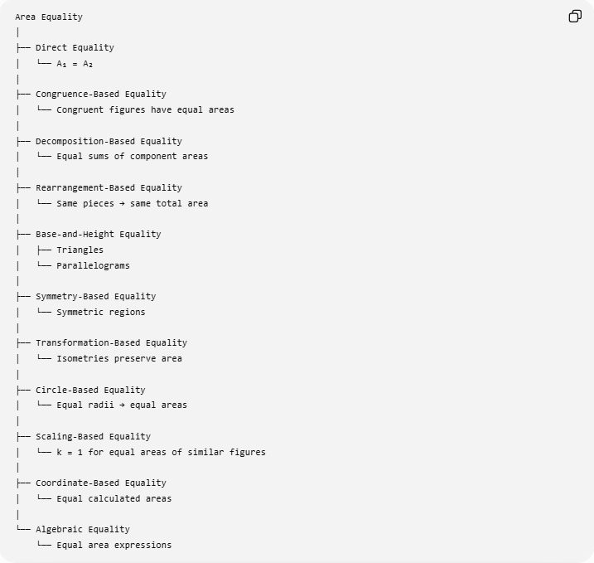
Area Equality
│
├── Direct Equality
│ └── A₁ = A₂
│
├── Congruence-Based Equality
│ └── Congruent figures have equal areas
│
├── Decomposition-Based Equality
│ └── Equal sums of component areas
│
├── Rearrangement-Based Equality
│ └── Same pieces → same total area
│
├── Base-and-Height Equality
│ ├── Triangles
│ └── Parallelograms
│
├── Symmetry-Based Equality
│ └── Symmetric regions
│
├── Transformation-Based Equality
│ └── Isometries preserve area
│
├── Circle-Based Equality
│ └── Equal radii → equal areas
│
├── Scaling-Based Equality
│ └── k = 1 for equal areas of similar figures
│
├── Coordinate-Based Equality
│ └── Equal calculated areas
│
└── Algebraic Equality
└── Equal area expressions

Relationship to Geometric Equality
# Source: AI Source: Provided by: [Data Path: Persons Table -> ID Column: 1, Name_En Column: Motasem Essam] -> From: [ChatGPT] on [7/25/2026]
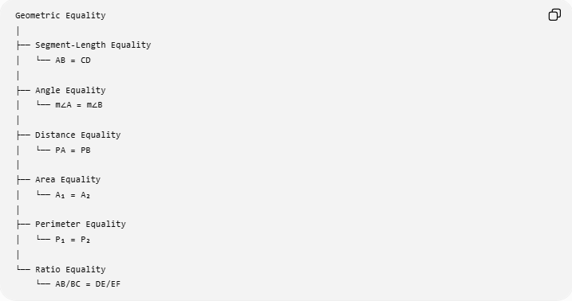
Geometric Equality
│
├── Segment-Length Equality
│ └── AB = CD
│
├── Angle Equality
│ └── m∠A = m∠B
│
├── Distance Equality
│ └── PA = PB
│
├── Area Equality
│ └── A₁ = A₂
│
├── Perimeter Equality
│ └── P₁ = P₂
│
└── Ratio Equality
└── AB/BC = DE/EF
Thus:
$$\boxed{\text{Area Equality is a type of Geometric Equality}}$$
It compares two-dimensional measurements, rather than lengths, angles, or distances.

Key Points
# Source: AI Source: Provided by: [Data Path: Persons Table -> ID Column: 1, Name_En Column: Motasem Essam] -> From: [ChatGPT] on [7/25/2026]
- Area Equality means two or more regions have exactly the same area.
- Its basic form is:
$$\boxed{A_{1}=A_{2}}$$
- Equal-area figures do not need to have the same shape.
- Congruent figures always have equal areas.
- Equal area does not imply congruence.
- Decomposition and rearrangement are important methods for establishing equal areas.
- Triangles with equal bases and equal heights have equal areas.
- Parallelograms with equal bases and equal heights have equal areas.
- Isometries preserve area.
- Equal-radius circles have equal areas.
- Similar figures generally do not have equal areas unless their scale factor is $1$.
- Coordinate geometry and algebra can be used to calculate and prove area equality.
- Area equality is exact:
$$A_{1}=A_{2}$$
rather than approximate:
$$A_{1}≈A_{2}.$$

Conclusion
# Source: AI Source: Provided by: [Data Path: Persons Table -> ID Column: 1, Name_En Column: Motasem Essam] -> From: [ChatGPT] on [7/25/2026]
Area Equality is the exact equality of the areas of two or more geometric regions. It can be established through direct measurement, congruence, decomposition, rearrangement, base-and-height relationships, symmetry, transformations, circle properties, coordinate geometry, and algebraic calculations.
Its central relationship is:
$$\boxed{\text{Area Equality}=\text{Same Exact Two-Dimensional Measure}}$$
And an important logical distinction is:
$$\boxed{\text{Congruence}⇒\text{Area Equality}}$$
but:
$$\boxed{\text{Area Equality}⇏\text{Congruence}}$$

